Evidence-Aware Pre-Payment Risk Assessment for UPI Transactions Using Payer Behaviour, Payee History, and an Incremental Payment Graph
Chinthada Murali Naga Raju, Chigurupati Vanya Kishore, Gudivada Yaswanth Naga Duga Prabhas, Bethapudi Vivek, and K. Kishore Raju
Department of Information Technology, Sagi Rama Krishnam Raju Engineering College (A), Bhimavaram, Andhra Pradesh, India (affiliated to Jawaharlal Nehru Technological University, Kakinada)

Abstract
In instant payment systems such as India’s Unified Payments Interface (UPI), transfers settle within seconds, so the useful opportunity to prevent a loss comes before the payment is submitted. This matters most for payer-authorised deception, in which the legitimate account holder is persuaded to pay a fraudster and the payer’s own behaviour offers little signal. This paper presents an advisory pre-payment risk-assessment architecture. It combines ten evidence families, spanning payer behaviour, observed payee history, an incrementally maintained payer–payee graph, payment-address and QR analysis, amount, message, link and stated-purpose context, and a calibrated gradient-boosting classifier. Each family reports its availability and the underlying facts it relies on, so that risk is reported separately from evidence coverage and corroboration is credited only across distinct observations. Because labelled UPI fraud data are not public, the classifier is evaluated on a synthetic corpus of 120,000 payments from 2,000 payers with a fraud prevalence of 1.183%. The running prototype retains a 12-feature model (V1). On the same held-out test split, V1 reaches a PR-AUC of 0.4860. An expanded 47-feature research representation (V2), frozen and evaluated offline, reaches a PR-AUC of 0.7326, a ROC-AUC of 0.9900, a recall of 0.7803 at a false-positive rate of 0.00995, and a Brier score of 0.00555. Social-engineering recall rises from 19.23% to 65.93%. The V2 graph, message, link and purpose channels are generated by the same simulator. These results therefore characterise the classifier under controlled synthetic conditions, not real-world performance. The complete ten-family verdict system was not benchmarked end to end.
Index Terms—Authorised push payment fraud, behavioural analytics, evidence aggregation, explainable machine learning, fraud risk assessment, pre-payment assessment, transaction graph, Unified Payments Interface (UPI).

1. Introduction

1.1 Background and Motivation
Retail payments in India have moved rapidly toward the Unified Payments Interface (UPI), an interoperable real-time payment system. A payer addresses a recipient through a virtual payment address (VPA), a mobile number or a QR code, and funds move between bank accounts within seconds [1]. Immediacy, low friction and availability at any hour make such systems attractive, but they also change the economics of fraud. When a transfer settles almost instantly and is difficult to reverse, the practical opportunity to prevent loss lies in the short interval between the payer’s decision to pay and the submission of the payment. Detection after settlement supports investigation and recovery, but it cannot restore funds that have already been moved onward.
Payment fraud detection has long been treated as statistical classification over transaction records, in which a transaction is compared with the history of the account that made it [2]. Operational studies have shown that the problem departs from textbook classification: fraud is rare, labels arrive late, patterns drift, and investigators can review only a limited number of alerts [3]. Instant payments add a further constraint. The relevant decision is no longer whether a completed transaction was fraudulent, but whether a payment that has not yet been made should proceed, proceed with a warning, or be verified first.

1.2 Problem Context
Two broad forms of payment fraud can be distinguished. In the first, an attacker gains control of an account or credential and initiates payments the owner did not authorise. In the second, the owner initiates and authenticates the payment personally after being deceived — for example by an impersonated official, a fraudulent seller, a fake refund process or a message that manufactures urgency. The second form is commonly called authorised push payment (APP) fraud. It has attracted regulatory attention because the victim’s own authentication makes the payment appear legitimate to the payment system [4].
The distinction affects detection design. Behavioural anomaly detection assumes that fraud leaves a trace in the payer’s own activity. When a deceived payer pays at a familiar hour, from a familiar device and for an ordinary amount, payer-side features may look normal. The more informative observations then concern who is being paid, how that recipient has been paid by others, the address or QR code used to identify it, and the message that prompted the payment. A recipient that collects proceeds from many victims tends to be recently observed and to receive payments from many unrelated payers who rarely return. Graph-based methods exploit such relational structure [5], [6], and recent work stresses that transaction graphs evolve continuously, so relational evidence benefits from incremental maintenance [5] and temporal information [7].
Combining heterogeneous evidence raises two further difficulties. The first is missing information. A payee who has never been observed is not the same as a payee known to be suspicious, yet substituting default values for unavailable measurements can silently turn “unknown” into a specific and possibly misleading input. The second is correlated evidence. When several components examine the same underlying observation, rewarding their agreement as independent confirmation overstates the strength of the evidence. An assessment intended to support a human decision must also be explainable.

1.3 Research Gap
Much of the transaction-level literature evaluates classifiers on completed records and emphasises deviations in the payer’s behaviour [2], [3]. Graph-based approaches exploit relational structure, but they are usually formulated as detectors over the whole graph — identifying dense collusive groups [5], [6] or learning node representations [7] — rather than as a source of evidence for a single payment request that has not yet been made. The UPI-specific study reviewed here applies an XGBoost classifier with SMOTE oversampling to transaction features and reports accuracy [8]. In the works reviewed for this study, contextual signals such as address integrity, QR consistency, message coercion and link reputation are rarely combined with payer and payee evidence in one assessment. Those works also do not generally describe how unavailable evidence is represented, or how correlated signals are kept from counting as independent corroboration.

1.4 Proposed Approach and Scope
This study develops an evidence-aware pre-payment risk-assessment architecture for UPI-style payments. It is an advisory decision-support layer that assesses a payment request, identified by a scanned QR payload, a VPA or a mobile number, before submission. It is not a payment processor, bank, payment service provider (PSP) or part of the national switching infrastructure. It does not execute, hold or settle payments, and it is not integrated with the National Payments Corporation of India (NPCI) or any bank or PSP.
For each request, ten evidence families are evaluated. Each reports a score, whether it was able to observe anything, and the underlying facts on which its score rests. An aggregation rule combines the available scores: the strongest signal leads, further signals contribute with diminishing weight, and a corroboration bonus is granted only for agreement across distinct facts. The output is a risk score, a separate coverage (evidence-confidence) score, one of four advisory verdicts, and human-readable findings.
Two classifier generations are reported, and they are kept distinct throughout. The running prototype retains V1, a compact 12-feature representation, which serves as the baseline. V2 is an expanded 47-feature research configuration that was frozen and evaluated offline; it is the primary predictive result of this paper, but it is not deployed. The predictive experiments evaluate the classifier component on synthetic data. The incremental graph and the evidence-aggregation logic are validated separately through software tests, and the complete ten-family verdict system is not benchmarked end to end.

1.5 Contributions
The contributions of this work are as follows.
- An integrated pre-payment risk-assessment architecture for UPI-style payments that combines payer behavioural evidence with payee history, payer–payee relational information and contextual evidence from the payment address, QR payload, amount, message, links and stated purpose.
- An evidence-aware aggregation mechanism in which each evidence family declares its availability and the typed facts its score relies on. Risk is reported separately from coverage. An unavailable family contributes no rule-based score, and double counting is limited when several families rest on the same observation.
- An incrementally maintained payer–payee graph that supplies explicit relational quantities — distinct payers, repeat behaviour, arrival timing, component membership and bounded neighbourhood overlap — to the live assessment path without rebuilding the graph for each request.
- A reproducible evaluation of the classifier component on severely imbalanced synthetic data. The operating threshold is chosen on a validation split and the model is measured once on a held-out test split. The evaluation compares the running V1 baseline with the offline V2 representation, and it is complemented by software validation of the graph and aggregation logic.

1.6 Paper Organisation
Section 2 reviews related work. Section 3 formulates the pre-payment assessment problem and the design objectives. Section 4 describes the system architecture, and Section 5 gives its mathematical formulation. Section 6 describes data construction and feature engineering, Section 7 the fraud-risk models, and Section 8 evidence aggregation and explainability. Section 9 sets out the experimental methodology and Section 10 the results. Section 11 discusses the findings, Section 12 examines threats to validity and limitations, and Section 13 concludes with future work.

2. Related Work

2.1 Behavioural and Transaction-Level Fraud Detection
Statistical treatments of fraud detection established the problem’s defining characteristics: fraud is a small minority, missed fraud and false alarms carry very different costs, and fraudsters adapt to deployed controls [2]. Behavioural detection characterises what is normal for an account — typical amounts, hours, frequency and counterparties — and scores new transactions by their deviation. Velocity measures capture the bursts typical of card testing and of an attacker draining a compromised account, and amount ratios capture unusually large transfers. Studies based on operational card data show that realistic evaluation must account for the limited number of alerts that can be investigated, delayed labels and concept drift [3]. These features work well when fraud changes the account’s observable behaviour, as in account takeover. They weaken when a deceived payer behaves normally, which is the situation of APP fraud. The present work keeps behavioural features but treats them as one view of a payment, alongside payee and contextual views that do not depend on the payer behaving unusually.

2.2 Graph-Based Fraud Detection
Graph-based methods make relational patterns explicit by representing accounts or merchants as nodes and interactions as edges. One line of work detects fraud as unusually dense subgraphs; FRAUDAR, for example, bounds the effect of camouflage edges that fraudsters add to legitimate nodes [6]. Graph neural networks (GNNs) instead learn node representations by aggregating information from neighbours. CARE-GNN addresses the fact that fraudsters can connect to benign nodes to dilute that aggregation [9], and graph convolutional networks have been applied to cryptocurrency transaction graphs to classify illicit flows [10]. These studies show that relational structure carries information that independent transaction features lack. However, they operate over a graph as a whole, and learned representations can be hard to explain to an individual payer. The present system performs neither dense-subgraph mining nor graph representation learning. It reads a small set of explicit, interpretable quantities from a maintained payer–payee graph and presents them as one evidence family among several.

2.3 Dynamic and Temporal Transaction Graphs
Payment graphs change as transactions arrive. Spade+ addresses dynamic graphs for dense-subgraph fraud detection in an industrial deployment. It maintains the peeling order on which dense-subgraph algorithms depend under both edge insertions and deletions, so suspicious communities can be updated without full recomputation, and it lets developers define their own suspiciousness functions [5]. PGLTSE treats time as information to be learned: it models transactions as a continuous-time dynamic graph and combines entity-level and transaction-relation-level graph learning with gang-aware risk propagation to detect organised fraud [7]. The present study shares the motivation for incremental maintenance and temporal awareness but reproduces neither method. Its graph is updated when each payment is recorded, within the same storage transaction. The assessment path reads the maintained quantities rather than rebuilding the graph, and the resulting features feed a classical calibrated classifier and a rule-based evidence aggregator.

2.4 UPI and Authorised Push Payment Fraud
Research on UPI has examined its role in digital payments and financial inclusion [1]. APP fraud has been examined mainly from legal and regulatory perspectives, including how losses should be allocated between customers and providers [4]. Its defining feature for detection is that the legitimate owner authenticates the payment, so controls that verify identity offer no protection when that person has been manipulated. Peer-reviewed work on UPI fraud detection is comparatively limited. Rani et al. describe a system that combines SMOTE oversampling, principal component analysis and an XGBoost classifier with a monitoring interface, and compare algorithms by accuracy [8]. Accuracy can remain high under a low fraud rate even for a classifier that misses most fraud, so those figures cannot be compared numerically with the precision–recall measures used here.

2.5 Evaluation Under Class Imbalance
When negatives vastly outnumber positives, a small false-positive rate can still produce many false alarms per true detection. Saito and Rehmsmeier showed empirically that precision–recall plots are more informative than receiver operating characteristic (ROC) plots for imbalanced data [11]. Davis and Goadrich analysed the relationship between the two curve families and showed that a larger area under the ROC curve does not imply a larger area under the precision–recall curve [12]. For fraud detection, recall at a fixed false-positive budget and the precision of the resulting alerts are directly interpretable operating characteristics [3].

2.6 Probability Calibration
Many classifiers, boosted trees among them, produce scores that are not reliable probabilities. Post-hoc calibration with sigmoid or isotonic mappings can correct this [13], [14]. Calibration matters whenever a probability is combined with other evidence or compared against fixed breakpoints, as it is in this architecture. The Brier score, the mean squared difference between predicted probability and outcome, reflects both calibration and discrimination [15].

2.7 Learning Methods and Data for Fraud Modelling
Gradient boosting builds an additive model of regression trees fitted sequentially to the gradient of a loss [16], and ensembles of trees are widely used for heterogeneous tabular fraud features. Because labelled payment data are rarely released, synthetic simulation is an established substitute. PaySim, for example, generates mobile-money transactions from an agent-based model calibrated on aggregate statistics of a real service [17]. Class imbalance is often addressed by resampling, such as interpolation-based minority oversampling [18], which changes the class prior the model learns. An alternative is to keep the data distribution, re-weight classes during training, and restore probabilistic meaning through calibration. That is the route taken in this work. Histogram-based gradient boosting accelerates tree construction by discretising continuous inputs [19].

2.8 Explainability
Additive feature-attribution methods such as SHAP decompose an individual prediction into contributions from its inputs [20]. Standard implementations of these learners and diagnostics are provided by scikit-learn [21], and permutation-based feature importance originates with random forests [22]. For an advisory system addressed to a payer, however, explanations are most useful when they refer to observations the payer can check, such as the age of a payee’s address or a mismatch between a QR code’s displayed name and its address. The present system therefore gives user-facing reasons at the level of evidence findings and uses model-level attributions as a complementary view of the classifier.

2.9 Summary of the Gap
The reviewed literature supplies the ingredients that a pre-payment assessment requires but seldom assembles them for that purpose. Transaction-level methods model the payer well but are weak when the payer has been persuaded to act normally [2]–[4]. Graph-based and temporal methods capture relational structure [5]–[7], [9], [10], but not as explicit, per-request evidence computed before payment and explained to the payer. The UPI-specific study reviewed here evaluates a transaction-feature classifier by accuracy [8]. This leaves room to investigate an architecture that combines complementary evidence families, maintains relational quantities incrementally, represents missing evidence explicitly, and aggregates evidence according to the observations each family relies on. The approach is evaluated with imbalance-appropriate metrics [11]–[15].

3. Problem Formulation and Design Objectives

3.1 The Pre-Payment Assessment Problem
Consider a payer who is about to authorise a UPI-style push payment. At assessment time the payment has not been submitted, so the only information available is the request and what has been observed before that moment. A payment request is written as
$$x=\{u, p, a, t, q, m, l\} \left(1\right)$$
where $u$ is the payer, $p$ the payee identifier (a VPA, a mobile number or an address extracted from a QR payload), $a$ the proposed amount, $t$ the assessment time, $q$ the raw QR payload if one was scanned, $m$ the message that prompted the payment if the payer supplies it, and $l$ the set of links carried by that message or payload. Any component other than $p$ and $t$ may be absent, denoted $⌀$. The amount is often unknown when a QR code without an embedded amount is scanned, and the message and links exist only when the payer provides them.
The task is to compute three quantities before submission:
- a risk score $R\left(x\right)∈\{0,…,99\}$, expressing how strongly the available evidence indicates that the payment should not proceed as requested;
- a coverage score $C\left(x\right)∈\{0,…,100\}$, referred to in this paper as evidence confidence, expressing how much of the designed evidence was actually available; and
- an advisory verdict $V\left(x\right)∈\{\text{APPROVE},\text{WARN},\text{STEP_UP},\text{BLOCK}\}$.
The verdict is advisory. APPROVE states only that the computed risk is below the configured intervention threshold; it is not a guarantee that the payment is safe.

3.2 Information Available Before Payment
Let $H_{<t}$ be the set of payment observations recorded strictly before $t$. These include the payer’s confirmed payments, payments imported from the payer’s bank or application statements, and payments confirmed through the system by other users. Three views are derived from it: the payer’s profile $H_{<t}\left(u\right)$, the payer’s history with the payee $H_{<t}\left(u,p\right)$, and the payee’s history across all observed payers $H_{<t}\left(⋅,p\right)$. A payer–payee graph $G_{<t}$ is maintained from the same observations (Section 4.4). Settlement outcomes, later complaints, the payee’s subsequent behaviour and the fraud label are unavailable at time $t$ by construction, and the live path is designed so that none of them can enter an assessment.

3.3 Design Constraints
The architecture is designed around eight constraints.
C1. No post-decision information. Every quantity used to assess $x$ in the live path must be computable from $x$, $H_{<t}$ and $G_{<t}$. The observation for $x$ is written only after the payer confirms the payment.
C2. Missing evidence is not evidence of safety. When a source cannot be read, the assessment must not become more favourable because that source contributed nothing.
C3. Missing evidence is not evidence of fraud. An unavailable family must not contribute a rule-based score. A measured absence — for example, that the deployment has never observed any payment to an address — is a different situation. It is treated as a low-weight finding that cannot by itself move a payment into the WARN band. Inside the classifier, missingness is an explicit input whose learned effect is monitored (Section 6.2).
C4. No double counting. A single underlying observation reported by several components must not be credited as independent corroboration.
C5. Interpretable findings. Every non-zero rule-based contribution to risk must be traceable to a named finding that can be stated in plain language.
C6. Risk is separate from availability. How much evidence exists and what it indicates are reported as different quantities.
C7. Operation before payment. The assessment must be computed during the payer’s decision, without recomputing history or graph state per request.
C8. No claimed provider verification. A payee must not be presented as verified by a bank, a PSP or the national switch unless such verification has actually been obtained.

3.4 Entity and Relationship Status
The entity status $σ\left(p\right)∈\{\text{UNKNOWN},\text{OBSERVED},\text{REGISTERED},\text{VERIFIED}\}$ describes the payee address. It is resolved in fixed precedence: VERIFIED if an external verification record exists; REGISTERED if the address belongs to a registered user; OBSERVED if payments to it appear in $H_{<t}$; and UNKNOWN otherwise. None of these values is a verdict, and the entity status is not an input to the risk score. The repository contains an optional provider-verification interface that is not configured. The prototype therefore produces no external verification records, and no payee in this study is VERIFIED (constraint C8).
The relationship status $κ\left(u,p\right)∈\{\text{ESTABLISHED},\text{NEW},\text{UNKNOWN}\}$ describes the pair:
- ESTABLISHED when $H_{<t}\left(u,p\right)$ contains at least one payment;
- NEW when the payer’s history is readable and contains none;
- UNKNOWN when no authenticated payer is available.
NEW is a measured absence, whereas UNKNOWN is the absence of a measurement. Imported bank statements do not always print a complete payee address; some print a truncated VPA fragment or only a counterparty name. History built from a fragment or a name is reported as partial identity and is not promoted to an established relationship with the exact address being paid.

3.5 Measured Zero Versus Unavailable
Each evidence family $i$ reports a pair $\left(a_{i},z_{i}\right)$, where $a_{i}∈\{0,1\}$ indicates availability and $z_{i}$ is its score:
$$a_{i}=1⇒z_{i}∈\{0,…,100\}, a_{i}=0⇒z_{i}=⊥ \left(2\right)$$
A value $z_{i}=0$ with $a_{i}=1$ means that the family looked and found nothing of concern; $a_{i}=0$ means that it could not look. The subscripted $a_{i}$ (availability) is distinct from the unsubscripted amount $a$.

3.6 Evidence Levels
Three families carry most of the information specific to a payment: payer behaviour, payee history and relationship. The evidence level $L\left(x\right)∈\{\text{FULL},\text{PARTIAL},\text{MINIMAL}\}$ is:
- FULL when all three are available;
- PARTIAL when at least the payer-behaviour or payee-history family is available;
- MINIMAL otherwise.
The payee-history family is available whenever an address can be read — including for an address never observed, which receives an explicit low-weight “unseen payee” finding. MINIMAL therefore arises only when no address can be read, and such a request is already blocked by a hard-block finding. For well-formed requests, the level distinguishes FULL from PARTIAL, and the coverage score gives the finer measure of availability.

3.7 Design Objectives
The design pursues four objectives. First, it aims to detect payer-authorised deception by giving payee-side and relational evidence a direct route to the risk score. Second, it keeps each rule-based contribution attributable to a named observation. Third, it degrades predictably as evidence disappears: fewer available families lower coverage without changing the meaning of the risk score. Fourth, it bounds per-request cost so that relational evidence can be read during the payer’s interaction.

4. Proposed System Architecture

4.1 Overview
The system comprises a client application, an assessment service and a persistent store (Fig. 1). The client decodes a QR code or accepts a typed address, and optionally collects the amount, a stated purpose and the message that prompted the payment. The assessment service evaluates the request against ten evidence families, aggregates them, and returns the risk score, coverage score, evidence level, verdict and findings. The store holds the payment-observation ledger, per-payee reputation aggregates, the incremental payer–payee graph and payer profiles. The prototype uses a TypeScript client, a Python FastAPI service, a scikit-learn classifier and an SQLite store.
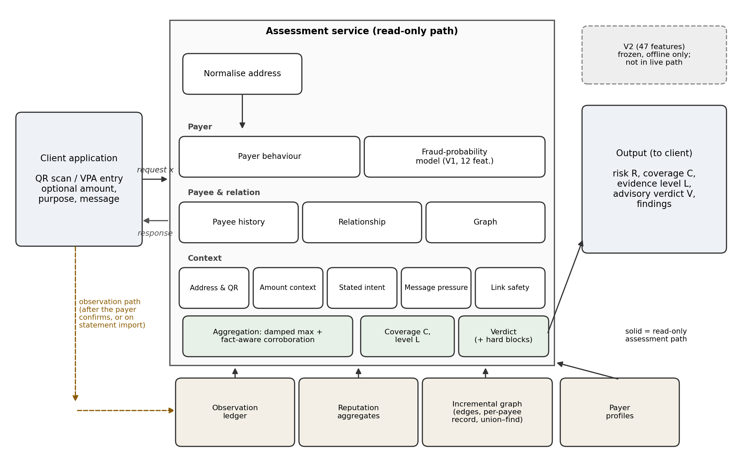
Fig. 1. System architecture. The assessment path (solid arrows) reads the store and never writes to it. Payments enter the ledger, reputation aggregates and graph only through the observation path (dashed), after the payer confirms a payment or imports a statement. The live classifier family uses V1; V2 is frozen and evaluated offline and is not part of the live path.

4.2 Pre-Payment Workflow and Observation Path
Two paths touch the store (Fig. 2). The assessment path only reads it. The observation path writes to it, and it runs only when a payment is recorded — when the payer confirms that a checked payment was made, or when a statement is imported. Because of this separation, the request being assessed cannot influence the state it is assessed against in the live system.
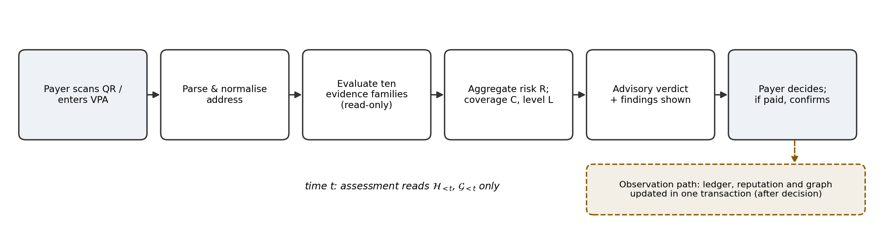
Fig. 2. Pre-payment workflow. The assessment for a request at time t reads only state recorded before t; the observation path updates the ledger, reputation aggregates and graph in one transaction after the payer’s decision.
All payment addresses pass through a single normalisation function before storage or lookup. Every recorded payment is written to the observation ledger with a provenance label:
- SYSTEM_CONFIRMED for payments confirmed through the assessment flow;
- STATEMENT_OBSERVED for payments parsed from an imported statement;
- OTHER_OBSERVED for other sources.
A deduplication key ensures that a payment reaching the ledger by two routes is recorded once. Statement ingestion classifies each counterparty field as a complete VPA, a partial VPA fragment, a non-VPA identifier, a name only, or unknown; only complete VPAs are joined to a payee address directly. Timestamps are normalised to Indian Standard Time (IST).

4.3 Evidence Families
Each of the ten families returns an evidence record containing its availability, score, severity, findings and a set of facts. Facts are drawn from a closed vocabulary of fourteen underlying observations:
- payer-side: AMOUNT_DEVIATION, HOUR_ANOMALY, VELOCITY_DAILY, VELOCITY_HOURLY and PAYER_RELIABILITY;
- payee-side: PAYEE_SHAPE, PAYEE_REPORTS, PAYEE_FAMILIARITY and GRAPH_POSITION;
- context: ADDRESS_INTEGRITY, AMOUNT_ABSOLUTE, LINK_REPUTATION, STATED_PURPOSE and MESSAGE_COERCION.
Facts identify what was observed, independently of which family observed it. The record constructor rejects an unavailable record that carries a score or facts.
Address and QR. This family checks whether the address is well formed and its handle plausible, whether the address contains visually confusable characters, and whether a QR payload is a payment request and whether its displayed payee name matches its address. It is always available. A malformed address or a non-payment payload is a hard-block finding (Section 5.11).
Payee history. This family reads the reputation aggregates for the payee across all observed payers: observation age, distinct payers, repeat payers, amount uniformity, and user reports or blocks. It is available whenever an address can be read. For an address with no recorded payments it raises the finding “unseen payee” with a weight of 6 points. This records that the deployment has no history for the address, which is ordinary for a new payee but also true of a newly created collection account. Six points is well below the 22-point WARN threshold, so a new payee does not become WARN on this finding alone.
Payer behaviour. This family compares the request with the payer’s own profile: amount relative to the payer’s typical payment, hour relative to usual hours, the day’s payment count relative to the payer’s average, novelty of the payee to this payer, and the payer’s record of failed payments. It requires a payer profile.
Relationship. This family reports $κ\left(u,p\right)$ and the pair’s history state (paid once, paid often, new to this payer but observed elsewhere, or partial identity). Its score is always zero. It contributes coverage and the PAYEE_FAMILIARITY fact, and it is unavailable without an authenticated payer.
Amount context. This family evaluates the amount against the per-transaction rail limit and against the size of transfer that is plausible to an unfamiliar payee. An amount above the rail limit is a hard-block finding. The family is unavailable when the amount is unknown.
Stated intent, message pressure and link safety. When the payer states a purpose, the stated-intent family checks it against known pretexts (such as a refund or a payment the other party requested) and against the payee type. When the payer supplies a message, the message-pressure family estimates coercive pressure from cues such as claimed authority, urgency, fear, credential requests, secrecy and offers of remote assistance. The link-safety family inspects URLs, for example for brand–domain conflict; it is always evaluated and scores zero when no link is present.
Fraud-probability model. This family obtains a calibrated probability from a gradient-boosting classifier and maps it to a bounded score (Section 5.7). In the running prototype the classifier is V1. The family requires a known amount, a payer profile and at least five prior payments.
Graph. This family reads the incremental payer–payee graph (Section 4.4). Only positional findings contribute to its score.

4.4 Incremental Payer–Payee Graph
The graph is maintained incrementally on the observation path. Each recorded payment from $u$ to $p$ does three things:
- updates a directed edge $\left(u,p\right)$ that carries a payment count and first and last timestamps;
- updates a per-payee aggregate record;
- merges the connected components of $u$ and $p$ in a union–find structure.
These updates execute in the same database transaction that records the payment, so the graph cannot drift from the ledger. The per-payee record holds the distinct-payer count, the repeat-payer count, the payment count, and the first and last arrival and activity times. Components are only ever merged, which matches an append-only ledger (Fig. 3).
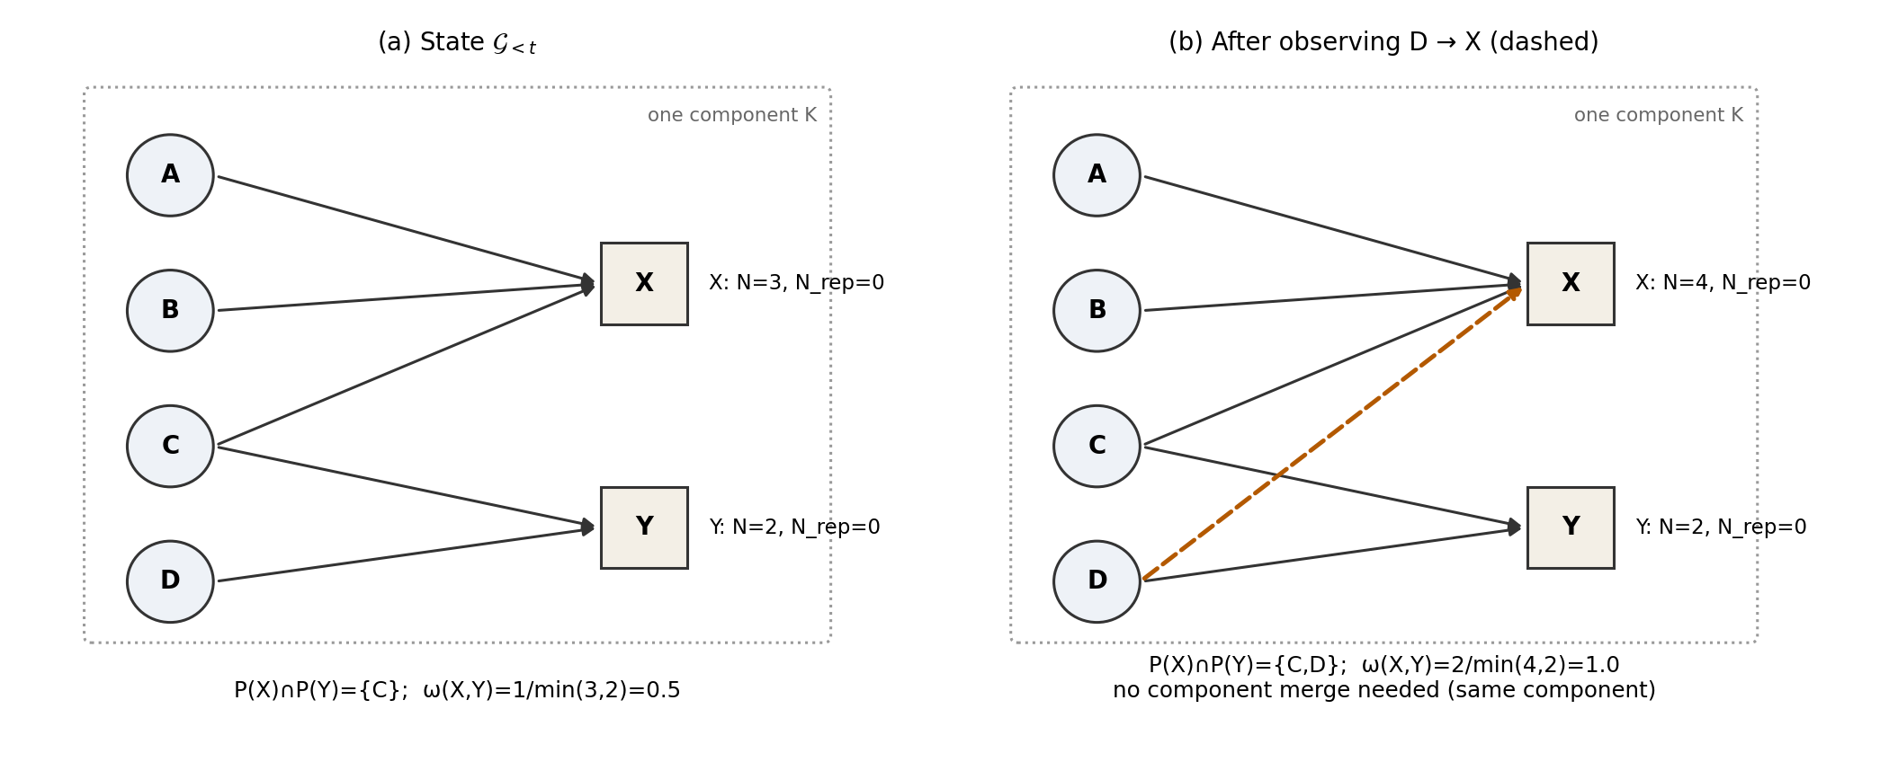
Fig. 3. Illustrative incremental payer–payee graph (not experimental data). (a) Payee X has three payers and Y two; they share payer C, so ω(X,Y) = 0.5. (b) After a new observation D → X, the shared set is {C, D} and ω(X,Y) = 1.0. No finding would fire, because the implemented gates require at least ten payers on each address.
The assessment path reads the graph through a read-only view that never rebuilds it. The shape quantities come from one indexed lookup, and the overlap quantity from a bounded two-hop query that finds the peer payee sharing the most payers with $p$.
Two kinds of finding are distinguished. Shape findings describe the payee’s own neighbourhood: many one-time payers, all payers arriving within a short window, or a high rate of payments from new payers. These restate what the payee-history family already scores, so in the graph family they carry zero weight and are tagged with the shared fact PAYEE_SHAPE. A position finding fires when a substantial share of the payee’s payers also pay a single other address and almost none of them pays either address twice. That pattern is consistent with collection accounts sharing a victim pool, and not with independent merchants, whose customers return. Only a position finding earns GRAPH_POSITION and a non-zero graph score. Component size is recorded but is not a finding, since most addresses in a connected payment network lie in one large component.
The component is explicit graph analytics. It is not a GNN, it learns no embeddings, and it performs neither dense-subgraph peeling as in Spade+ [5] nor temporal graph representation learning as in PGLTSE [7]. Explicit features can be named in a finding shown to a payer and computed within a single request, and they remain meaningful on the small, partially observed graph a single deployment sees. The cost is that they capture only patterns specified in advance.

4.5 Fraud-Probability Model
The classifier is a histogram-based gradient-boosting model with balanced class weights, wrapped in five-fold isotonic calibration. Its operating threshold is selected on a validation split. It is one evidence source among ten, not the decision-maker: it contributes a bounded score and cannot, as the only active family, reach the BLOCK band (Section 5.7).
V1 is the 12-feature representation served by the running prototype. V2 is a 47-feature research representation in nine groups that was frozen and evaluated offline and is not served (Section 6.4).

4.6 Aggregation and Verdict
The aggregation receives the ten evidence records. Risk is formed as a damped maximum over available family scores, plus a corroboration bonus that is granted only when distinct facts are reported by more than one family. Coverage is the weighted share of available families. The verdict follows from fixed risk bands, except that a small set of hard-block findings produces BLOCK directly (Section 5).

4.7 Explanation Interfaces
Explanations are produced at two levels.
Evidence level. Every assessment returns its findings, each with a severity, a plain-language message, the family that raised it and the facts that corroborated it. This is the primary user-facing explanation. Every non-zero rule-based contribution to risk comes from a named finding. The classifier’s contribution is expressed in the same vocabulary by attributing facts to it counterfactually (Section 5.7).
Model level. The prototype also provides an explanation interface: an /explain endpoint and an Explainability screen. For a recorded transaction, it computes model-agnostic SHAP values for the V1 feature vector against a stored background sample, using the calibrated V1 probability as the explained function. These attributions describe the classifier’s output. They are not the verdict, and they do not replace the evidence findings.
For the offline analysis in Section 10, SHAP values are instead computed with a tree explainer on the uncalibrated booster of the first calibration fold, so their magnitudes are on the booster’s raw scale (Section 7.7).

4.8 Deployment Boundary
The prototype runs as a mobile or web client in front of the assessment service. It is not integrated with NPCI, any PSP or any bank, and it does not initiate or intercept payments. The repository includes an optional provider-verification interface, which was not configured for this study, so no real-time external verification takes place. The payment history used consists of payments confirmed through the application and statements that users choose to import. Payee-side evidence is therefore limited to what the deployment itself has observed.

5. Mathematical Formulation

5.1 Notation and Clamped Mapping
Let $F=\{1,…,10\}$ index the evidence families, and let $h\left(t\right)$ be the IST hour of $t$. Wherever a measurement is converted into a score, the implementation uses a single clamped linear map:
$$g\left(v;v_{0},v_{1},y_{0},y_{1}\right)=y_{0}+\left(y_{1}−y_{0}\right) min​\left(1,max​\left(0,{v−v_{0}}/{v_{1}−v_{0}}\right)\right) \left(3\right)$$

5.2 Pre-Payment Temporal Boundary
With $τ\left(o\right)$ the time of observation $o$ in ledger $H$, the history available to a live assessment at $t$ is
$$H_{<t}=\{ o∈H:τ\left(o\right)<t \} \left(4\right)$$
The payer’s history with the payee is computed with this strict inequality explicitly. The reputation aggregates and graph, by contrast, are read in their current state. For a live request this coincides with the state before $t$, because the observation for $x$ is written only after confirmation. It does not coincide for a retrospective replay against a store that already contains later payments, and the prototype maintains no time-indexed aggregates. The boundary is therefore a property of the live assessment path. The offline corpus is sampled row by row and does not replay the live graph chronologically (Section 6.5).

5.3 Evidence Records
Family $i$ returns
$$e_{i}\left(x\right)=\left(a_{i}, z_{i}, Γ_{i}, Φ_{i}\right) \left(5\right)$$
with availability $a_{i}$, score $z_{i}$, findings $Γ_{i}$ and facts $Φ_{i}$, where $Φ_{i}$ is a subset of the fourteen-fact vocabulary $V$. When $a_{i}=0$, $z_{i}=⊥$ and $Γ_{i}=Φ_{i}=∅$. A family is active if $a_{i}=1$ and $z_{i}>0$. Each family maps its findings to a score by its own bounded rule. For the amount-context and graph families this is the sum of finding weights capped at 100, and the relationship family is fixed at $z=0$.

5.4 Payer Behavioural Quantities
Let $n_{u}$ be the payer’s number of prior outgoing payments and $b_{u}$ their median amount. The amount baseline is measurable only if $n_{u}≥5$ and $b_{u}>0$, in which case the relative amount is $a/b_{u}$. The time quantities are a night indicator and a circular distance from the payer’s most active hour ${\overset{‾}{h}}_{u}$:
$$ν\left(t\right)=1\left[h\left(t\right)<6∨h\left(t\right)≥22\right], d_{u}\left(t\right)=min\left(\left|h\left(t\right)−{\overset{‾}{h}}_{u}\right|, 24−\left|h\left(t\right)−{\overset{‾}{h}}_{u}\right|\right) \left(6\right)$$
Velocity is described by three quantities: the time since the previous payment, capped at one day; the number of payments in the preceding hour; and today’s count divided by the payer’s average daily count. The payer-behaviour rules produce a raw score $r_{u}$, which is converted as
$$z_{\text{pb}}=\left\{\begin{matrix}0, & r_{u}<25 \\ round\left(g\left(r_{u};25,85,12,52\right)\right), & r_{u}≥25\end{matrix}\right. \left(7\right)$$
so that an ordinary payment does not place a permanent floor under risk.

5.5 Payee and Relationship Quantities
For payee $p$, let $N_{p}$ be the number of distinct payers, $N_{p}^{\text{rep}}$ the number who paid more than once, and $A_{p}$ the days since first observation. The repeat ratio is
$$r_{p}=\frac{N_{p}^{\text{rep}}}{max\left(N_{p},1\right)} \left(8\right)$$
and it is treated as measurable only when $N_{p}≥5$; the counts themselves are exact and are used at any size. The payer-relative novelty indicator is $η\left(u,p\right)=0$ if $κ\left(u,p\right)=\text{ESTABLISHED}$ and $1$ if $κ\left(u,p\right)=\text{NEW}$. When no payer is available, it falls back to whether $p$ has been observed at all.

5.6 Graph State and Graph Quantities
The graph state is
$$G_{<t}=\left(V_{<t},E_{<t}\right), P\left(p\right)=\{u:\left(u,p\right)∈E_{<t}\} \left(9\right)$$
with $V_{<t}$ containing payers and payees and $E_{<t}$ the payment edges. From the per-payee record the implementation derives the arrival span $S_{p}$, the lifespan $T_{p}$, the payment rate $λ_{p}$ and the component size $\left|K\left(p\right)\right|$. For a peer $p′$, the overlap ratio is
$$ω\left(p,p′\right)=\frac{\left|P\left(p\right)∩P\left(p′\right)\right|}{min\left(\left|P\left(p\right)\right|,\left|P\left(p′\right)\right|\right)} \left(10\right)$$
and $p^{⋆}$ is the peer that maximises the shared count, found by a bounded two-hop query. The overlap is not read unless both addresses have at least $N_{min}=10$ payers. It is also discounted when the peer’s own repeat ratio is at least $ϵ=0.1$, which is the signature of a merchant with returning customers. A position finding fires when $\left|P\left(p\right)∩P\left(p^{⋆}\right)\right|≥4$, $ω\left(p,p^{⋆}\right)≥0.6$ and $r_{p}<0.1$. The graph score is the capped sum of position-finding weights, and GRAPH_POSITION belongs to $Φ_{\text{gr}}$ if and only if a position finding has fired.

5.7 Classifier Probability and Its Evidence Score
Let $ϕ\left(x\right)∈R^{d}$ be the feature vector ($d=12$ for V1, $d=47$ for V2), with unmeasured entries left missing and routed natively by the learner. Let $θ$ be the threshold selected on validation. The calibrated probability is
$$π\left(x\right)=\hat{P}\left(y=1∣ϕ\left(x\right)\right) \left(11\right)$$
The classifier family is available only if the amount is known, a payer profile exists and $n_{u}≥5$. Its score is
$$z_{\text{ml}}=\left\{\begin{matrix}round\left(g\left(π;0,θ,0,18\right)\right), & π<θ \\ round\left(g\left(π;θ,0.80,30,66\right)\right), & π≥θ\end{matrix}\right. \left(12\right)$$
The ceiling of 66 lies below the BLOCK boundary of 70, so the classifier cannot produce BLOCK as the only active family.
Facts are attributed to the classifier counterfactually. For a candidate fact $v$, let $ϕ^{\left(−v\right)}\left(x\right)$ be a probe in which the inputs underlying $v$ are neutralised: the payee-history features are set to missing, and payer-side inputs are replaced by values that describe the payer’s ordinary behaviour. Then
$$v∈Φ_{\text{ml}}⇔π\left(x\right)−π\left(ϕ^{\left(−v\right)}\left(x\right)\right)≥max\left(0.01, 0.15 π\left(x\right)\right) \left(13\right)$$
The probes serve only to attribute facts and never alter $z_{\text{ml}}$.

5.8 Base Risk by Damped Maximum
Let $z_{\left(1\right)}≥z_{\left(2\right)}≥…≥z_{\left(n\right)}$ be the scores of the active families. The base risk is
$$R_{0}\left(x\right)=min\left(99, round\left(z_{\left(1\right)}+β\sum_{j=2}^{n}{z_{\left(j\right)}}\right)\right), β=0.4 \left(14\right)$$
with $R_{0}=0$ when no family is active. Unavailable families do not enter the sum. Available families with zero score also contribute nothing to $R_{0}$, but they count toward coverage (Fig. 4).
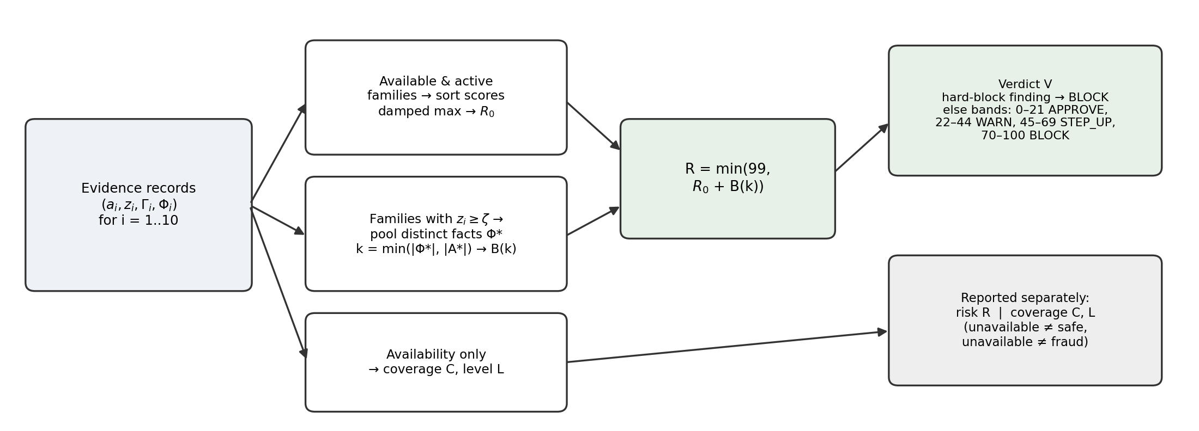
Fig. 4. Evidence aggregation. Risk is formed from the scores of active families by a damped maximum plus a fact-aware corroboration bonus. Coverage and evidence level depend only on availability and are reported separately. The verdict applies hard-block findings first and then the fixed risk bands.

5.9 Fact-Aware Corroboration
Let $A\left(x\right)=\{i:a_{i}=1,z_{i}≥ζ\}$ with $ζ=20$, let $Φ^{⋆}\left(x\right)=⋃_{i∈A}Φ_{i}$, and let $A^{⋆}\left(x\right)⊆A\left(x\right)$ be the participating families that report at least one fact. The corroboration strength and final risk are
$$k\left(x\right)=min\left(\left|Φ^{⋆}\left(x\right)\right|, \left|A^{⋆}\left(x\right)\right|\right), R\left(x\right)=min\left(99, R_{0}\left(x\right)+B\left(k\left(x\right)\right)\right) \left(15\right)$$
The bonus is $B\left(k\right)=0$ for $k<2$, and $B=6,14,22,28$ for $k=2,3,4,5$, rising to a maximum of 32 for $k≥6$. The family count keeps a single family from corroborating itself. The fact count keeps several families that read one observation from appearing to agree.

5.10 Coverage and Evidence Level
Coverage (evidence confidence) is
Cx=round​100⋅i​ai cii​ci 16
with fixed implementation weights $c_{i}$ summing to 100: payee history 24, relationship 18, payer behaviour 16, classifier 12, address and QR 11, graph 8, amount context 5, message pressure 3, link safety 2 and stated intent 1. They weight the evidential value of availability, not risk, and they play no part in $R\left(x\right)$. The evidence level $L\left(x\right)$ follows Section 3.6.

5.11 Verdict Mapping
Let $B$ be the hard-block set: a blocked payee, a malformed address, a non-payment payload, a missing payee, an empty request and an amount above the rail limit. With $Γ\left(x\right)=⋃_{i}Γ_{i}$,
$$V\left(x\right)=\left\{\begin{matrix}\text{BLOCK}, & Γ\left(x\right)∩B≠∅ \text{ or } 70≤R\left(x\right)≤100 \\ \text{STEP_UP}, & 45≤R\left(x\right)≤69 \\ \text{WARN}, & 22≤R\left(x\right)≤44 \\ \text{APPROVE}, & 0≤R\left(x\right)≤21\end{matrix}\right. \left(17\right)$$
Because $R$ is capped at 99, the BLOCK band covers 70–99 in practice. The four verdicts are advisory outputs of the aggregated risk score, not ground-truth classes.

6. Data Construction and Feature Engineering

6.1 Synthetic Transaction Corpus
Labelled UPI fraud data held by banks, PSPs and the national switch are not publicly released. This study used no private NPCI data, no bank-owned transaction corpus and no PSP production dataset. The classifier is instead trained and evaluated on a synthetic corpus produced by a purpose-written simulator, in the tradition of agent-based payment simulators such as PaySim [17]. The simulator supports controlled experiments with a known generating process and makes every reported number reproducible from a fixed seed. It does not establish how the system would perform on real UPI traffic.
The corpus is generated by a single call with 120,000 transactions, a nominal fraud rate of 0.012, 2,000 simulated payers and seed 42. The realised corpus contains 1,419 fraudulent transactions, a prevalence of 1.183% (Table I). Each payer receives:
- a typical amount drawn from a right-skewed log-normal distribution (median of approximately Rs 270);
- a usual hour of activity;
- a daily transaction rate;
- a number of habitual payees.
A 12% segment of payers makes large payments such as rent, fees and deposits as an ordinary matter. Without this segment, large amounts would occur almost only in fraudulent rows. All amounts respect the per-transaction UPI limit, and both classes can reach it.
Each transaction is generated for a randomly chosen payer, by one of four fraud scenarios with probability equal to the fraud rate and as legitimate activity otherwise. The scenario mixture is fixed at social engineering 50%, mule collection 22%, account takeover 20% and card testing 8%. These are simulator-controlled design choices, not estimates of the composition of fraud in the UPI ecosystem.
Labels are assigned by the generating process rather than by a rule over features. The scenarios are also built to overlap with legitimate behaviour:
- legitimate payers sometimes send large amounts to new payees;
- some account-takeover payments go to payees the victim had already paid;
- some social-engineering payees are aged accounts resembling small merchants.
Two separability artefacts found in earlier generator versions were removed before the reported experiments.
The corpus is row-level. Each row represents the state of the evidence at the moment one payment is about to be made, sampled from scenario-conditional distributions. It is not a time-ordered ledger replayed through the running system (Fig. 5).
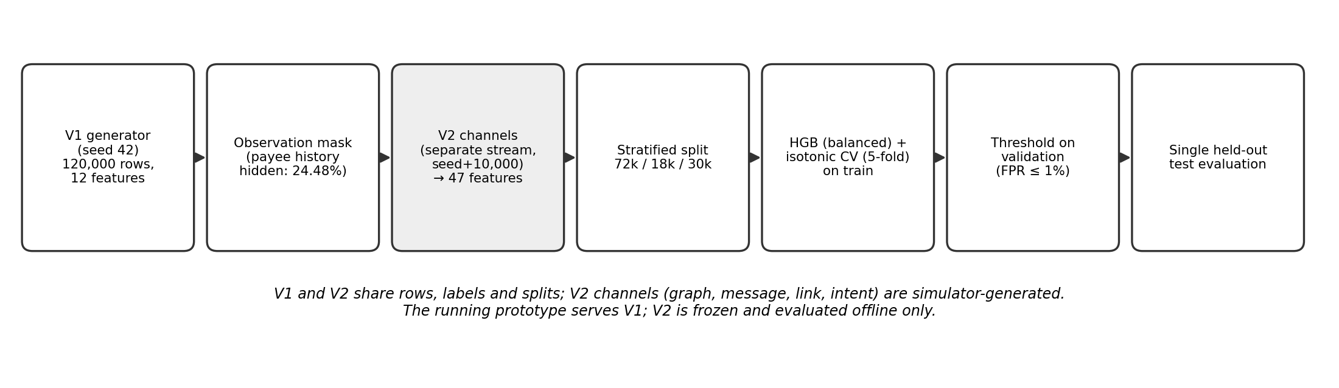
Fig. 5. Data and model pipeline. V1 and V2 share rows, labels and splits. The V2 channels are drawn by the simulator from a separate random stream. The running prototype serves V1; V2 is frozen and evaluated offline only.
TABLE I. Composition of the synthetic corpus (seed 42). Scenario proportions are simulator settings, not real-world prevalence estimates.
Item | Value
Transactions | 120,000
Simulated payers | 2,000
Fraudulent transactions (prevalence) | 1,419 (1.183%)
Training / validation / test rows | 72,000 / 18,000 / 30,000
Fraudulent rows per split | 851 / 213 / 355
Scenario mixture of fraud | Social engineering 50%, mule collection 22%, account takeover 20%, card testing 8%
Test-split fraud by scenario | Social engineering 182, mule collection 80, account takeover 73, card testing 20
Rows with hidden payee history | 29,376 (24.48%)

6.2 Behavioural and Payee Features (V1)
The V1 representation contains twelve features.
Payer and payment features (seven):
- amount: the proposed amount;
- amount_over_user_avg: the amount divided by the payer’s median prior payment;
- is_night: 1 between 22:00 and 06:00 IST;
- hours_from_usual: the circular distance from the payer’s most active hour;
- seconds_since_last_txn: the time since the previous payment, capped at one day;
- txns_last_hour: the payer’s payments in the preceding hour;
- txns_today_over_avg: the day’s payment count divided by the payer’s daily average.
Payee features (five):
- payee_is_new: whether this payer has not paid this payee before;
- payee_age_days: days since the payee was first observed;
- payee_distinct_payers: the number of distinct payers;
- payee_repeat_ratio: the share of those payers who paid more than once;
- payee_history_available: whether the payee’s history could be read at all.
Missing payee history. A deployment observes a payee only after one of its users, or an imported statement, has recorded a payment to it. An earlier pipeline substituted constants for missing payee values, which in effect described every unknown address as moderately established. The current pipeline substitutes nothing:
- when the payee’s history is unavailable, payee_age_days, payee_distinct_payers and payee_repeat_ratio are set to missing (NaN) and payee_history_available is set to 0;
- when a history exists but the payee has fewer than five distinct payers, the exact counts are kept and only the repeat ratio is set to missing.
A measured zero (for example, a repeat ratio of 0 over ten payers) is therefore distinguishable from an unavailable value. The histogram-based learner routes missing values natively [19], [21].
The simulator reproduces unavailability with an observation mask. The probability that a payee’s history is visible rises smoothly with its distinct-payer count, following a saturating curve with half-saturation at nine payers. In the evaluated corpus the mask hides payee history on 29,376 of 120,000 rows (24.48%). The simulated fraud prevalence is 1.729% among rows with hidden history and 1.005% among rows with visible history. This difference is a property of the simulator’s masking rule, which relates visibility to payer count, and it is not causal evidence that missing history indicates fraud.
The difference has one consequence that must be stated. At the aggregation level, an unavailable family contributes no rule-based score merely because it is unavailable. Within the classifier, however, payee_history_available is itself a feature, so missingness can influence the learned probability. The pipeline therefore reports the availability bias on every run, and automated tests bound it and check that the availability flag alone does not separate the classes strongly.

6.3 Graph-Derived Features
In the live system the incremental graph $G_{<t}$ supplies per-payee quantities (Section 5.6). The V2 representation includes seven graph features:
- arrival_span_days;
- lifespan_days;
- payments_per_day;
- component_size;
- shared_payer_peak, the largest number of payers shared with any single other payee;
- overlap_ratio;
- graph_available.
Raw degree is not treated as fraud evidence. Overlap is read only when both addresses have at least ten payers ($\text{MIN_FAN_IN}=10$), and it is discounted when the peer’s own payers commonly return, as a popular merchant’s do.
In the synthetic corpus these graph features are not computed by running the incremental graph over a simulated ledger. They are sampled per row from scenario-conditional distributions that mirror the production gates:
- the whole group is missing whenever payee history is hidden;
- the overlap ratio is missing below the ten-payer gate.
The predictive experiments therefore evaluate the contribution of graph-derived feature channels under a controlled simulation. The incremental graph implementation itself is validated separately through software tests (Section 10.12).

6.4 V1 and V2 Feature Representations
The running prototype retains V1, whereas V2 is an expanded research configuration that was frozen and evaluated offline (Table II).
V2 contains 47 features in nine groups:
- payer timing (2);
- amount (2);
- velocity (3);
- payee (5): the four V1 payee-history features plus whether the payee is a phone-number address;
- relationship (4): V1’s payee_is_new, prior payments to the payee, days since the first such payment, and an availability flag;
- graph (7);
- message (18): ten coercion-cue indicators, a coercion probability and score, a weak-cues flag, four text statistics, and an availability flag;
- link (3);
- stated intent (3).
The V2 generator first calls the V1 generator and keeps its output bit-for-bit — the same rows, order, labels and twelve column values. It then draws every additional column from a separate random stream with a seed offset of 10,000, and an automated check asserts that the V1 columns are unchanged.
The V2 channels are simulated. Whether a message accompanies a payment, which kind it is, whether it carries a link, and which purpose is stated are all drawn by the simulator from scenario-conditional probabilities chosen by the designers. These probabilities deliberately overlap; for example, a message is present on 55% of legitimate rows and 62% of social-engineering rows. Message texts come from a templated pool of 1,022 messages (364 scam, 557 hard negatives, 101 easy negatives) written for the project rather than collected from real traffic. The message and link features are computed by the same extractors the service uses. However, the coercion model that produces one message feature was fitted on the same templated pool. Improvements obtained by V2 are therefore evidence about the architecture under the simulator’s assumptions, not about production performance.
TABLE II. V1 and V2 feature representations.
Aspect | V1 (running prototype, baseline) | V2 (research configuration, offline)
Features | 12 | 47 in 9 groups
Groups | Payer timing, amount, velocity, payee (incl. payer-relative novelty) | V1 groups + payee phone-address flag, relationship, graph, message, link, stated intent
Missing values | NaN for unmeasured payee values; one availability flag | NaN plus availability flags for payee, relationship, graph, message and intent; link features missing when no message
Source of added channels | — | Simulator-generated (graph, message, link, intent, relationship)
Learner | HistGradientBoosting, balanced class weights, isotonic calibration (5-fold) | Same configuration
Threshold | Validation split, 1% FPR budget (0.1174) | Same rule (0.1123)
Status | Served by the running prototype | Frozen with hashed artefacts; evaluated offline only

6.5 Feature Integrity and Temporal Boundary
The live serving path is designed around pre-payment information. The assessment path is read-only, and a payment is written to the ledger, aggregates and graph only after the payer confirms it. The payer–payee history uses an explicit strict inequality on payment time, and the velocity inputs are filtered the same way. Automated tests check that a check leaves stored graph and reputation tables unchanged and that later observations do not alter an earlier reading.
The offline V2 experiment generates rows and graph-derived features through the synthetic simulator and does not replay the live graph cache chronologically. Its temporal boundary therefore holds by construction rather than by computation. Retrospective replay against a store that already contains later payments would not reproduce the pre-payment state, because aggregates are not time-indexed.
One limitation of V1 is reported as it stands. When the payer’s usual hour is unavailable, V1 records hours_from_usual as 0, the same value as a payment made exactly at the usual hour. An unmeasured deviation therefore cannot be distinguished from a measured zero deviation. V1 is a frozen artefact and has not been altered, and V2 inherits the same encoding for this feature.

7. Fraud Risk Modelling

7.1 Learning Problem
Given the feature vector $ϕ\left(x\right)$ and label $y∈\{0,1\}$, where 1 denotes fraud, the task is to estimate $π\left(x\right)$ in (11) and choose a threshold $θ$. At about 1.2% prevalence, a classifier that labels every payment legitimate is correct on almost 99% of payments, so accuracy is not used as a headline metric. The evaluation instead emphasises ranking quality under imbalance, recall at a fixed false-positive budget, and calibration [3], [11], [12].

7.2 V1 Model
V1 is a histogram-based gradient-boosted decision-tree model [16], [19], implemented with scikit-learn’s HistGradientBoostingClassifier [21] and wrapped in CalibratedClassifierCV with isotonic regression and five folds. The booster uses:
- 300 iterations;
- a learning rate of 0.08;
- at most 31 leaves per tree;
- balanced class weights;
- a fixed random state.
Five-fold calibration fits five booster–calibrator pairs whose calibrated probabilities are averaged. This is the standard mechanism of the wrapper, not a heterogeneous ensemble. Calibration matters because the probability is mapped onto an evidence score with fixed breakpoints (12) and is used for counterfactual fact attribution (13). The V1 evaluation artefacts also report a class-balanced logistic-regression reference on the same features and splits.

7.3 V2 Model
V2 applies the same modelling family to the expanded representation; no second algorithm is introduced. Its configuration was fixed in a validation-only phase in three steps:
- Four model families were compared on the full V2 features using the validation split: V1-configured gradient boosting; a random forest (300 trees, minimum leaf size 2, balanced-subsample weights); extremely randomised trees (300 trees, minimum leaf size 2, balanced weights); and logistic regression (balanced, standardised). The last three used median imputation. Candidates were ranked by validation PR-AUC and then by validation recall at 1% FPR.
- A feature-group ablation on the validation split selected the full nine-group set.
- The selected configuration was fitted, calibrated, given its threshold on validation, and frozen together with a dataset fingerprint, which includes hashes of the generators, the message corpus and the coercion weights.
The frozen configuration records that no test rows were used in any decision.

7.4 Class Imbalance
Four aspects of imbalance handling are kept distinct:
- Data prevalence. The corpus retains a prevalence of 1.183%, and each split is stratified to the same prevalence.
- Training weights. The booster uses balanced class weights, scaling each class’s loss contribution inversely to its frequency.
- No resampling. No SMOTE [18], random oversampling, undersampling or generative minority sampling is used.
- Calibration. Class weighting shifts the effective class prior and inflates minority-class scores, and isotonic calibration returns the probabilities to the observed scale.
Threshold selection is a fifth, separate step (Section 7.5).
On the evaluation side, a high ROC-AUC can coexist with an operationally unacceptable number of false alarms per true detection [11]. The operating point is therefore specified as a false-positive budget rather than as a threshold that maximises a symmetric criterion.

7.5 Threshold Selection
Probability estimation, threshold selection and final evaluation are separated. The calibrated model is fitted on the training split. On the validation split, $θ$ is chosen as the threshold that gives the highest recall among thresholds whose validation false-positive rate (FPR) does not exceed 1%. It is then applied unchanged to the test split.
The selected thresholds are 0.1174 for V1 and 0.1123 for V2. For V1, an independent re-derivation from the validation split agrees with the stored value to four decimal places. The evaluation artefacts record that neither test labels nor test features were used in selection. The threshold $θ$ belongs to the classifier; it is distinct from the verdict bands in (17).

7.6 Calibration
Calibration is assessed with the Brier score [15],
$$\text{BS}=\frac{1}{n}\sum_{j=1}^{n}{{\left(π_{j}−y_{j}\right)}^{2}} \left(18\right)$$
and with the Brier skill score $\text{BSS}=1−\text{BS}/{\text{BS}}_{\text{ref}}$. Here ${\text{BS}}_{\text{ref}}=0.01169$ is the Brier score of a constant predictor that always outputs the base rate. Reliability curves are reported with both quantile and fixed-width bins. At a 1% base rate most predictions lie near zero, so quantile edges collapse, and fixed-width bins make the sparsely populated upper range visible.

7.7 Explainability of the Classifier
Two model-level analyses are computed offline for V2:
- Permutation importance [22] is the mean decrease in test average precision over five permutations, computed on the calibrated model.
- SHAP values [20] are computed with a tree explainer on 200 test rows, applied to the uncalibrated booster of the first calibration fold. Their magnitudes therefore explain that booster’s raw output and are not decompositions of the calibrated probability. Isotonic calibration is monotone, so it preserves the ordering of predictions but not attribution magnitudes.
Separately, the prototype’s explanation interface computes model-agnostic SHAP values for V1 against the calibrated probability (Section 4.7). Neither form of attribution establishes causal influence.

8. Evidence Aggregation and Explainability

8.1 Evidence Families and Availability
Table III summarises the ten evidence families, their availability conditions, how each contributes to risk, and their coverage weights. The V1/V2 distinction applies to the classifier family only. In the running prototype all ten families are evaluated for every request, and the classifier family uses V1. Message, link, stated-purpose, relationship and graph evidence therefore reach the live risk score through their own rule-based families, whereas V2 receives those channels as classifier inputs and is not served.
TABLE III. Evidence families, availability and contribution to risk.
Family | Available when | Contribution to risk | Principal facts | $c_{i}$
Payee history | An address can be read | Scored; unseen payee → 6-point warning; blocked payee → hard block | PAYEE_SHAPE, PAYEE_REPORTS | 24
Relationship | Authenticated payer present | Informational ($z=0$) | PAYEE_FAMILIARITY | 18
Payer behaviour | Payer profile exists | 0 if raw score < 25, else 12–52 | AMOUNT_DEVIATION, HOUR_ANOMALY, VELOCITY_DAILY, PAYEE_FAMILIARITY, PAYER_RELIABILITY | 16
Classifier (V1) | Amount known, profile, ≥ 5 prior payments | 0–18 below $θ$; 30–66 above | Counterfactually attributed subset | 12
Address and QR | Always | Scored; malformed address or non-payment payload → hard block | ADDRESS_INTEGRITY | 11
Graph | Payee present in graph | Position findings only | GRAPH_POSITION; shape findings share PAYEE_SHAPE at zero weight | 8
Amount context | Amount known | Scored; over rail limit → hard block | AMOUNT_ABSOLUTE | 5
Message pressure | Message supplied | Scored; 0 if only weak cues | MESSAGE_COERCION | 3
Link safety | Always (0 if no link) | Scored | LINK_REPUTATION | 2
Stated intent | Purpose stated | Scored | STATED_PURPOSE | 1

8.2 Availability, Entity Status and Missing Evidence
An unavailable family carries no score, findings or facts, so it neither raises nor lowers the rule-based risk. “New” is different from “history unavailable”:
- an address that can be read but has never been observed keeps the payee-history family available, with the 6-point “unseen payee” warning;
- a family that cannot be evaluated at all is unavailable.
A new payee therefore does not become WARN on novelty alone, because 6 points is below the 22-point threshold. However, the novelty finding can combine with other evidence through the damped maximum.
Within the classifier, missingness is an input, as described in Section 6.2. The entity status (Section 3.4) is descriptive and is not scored, and no experimental payee is externally verified.

8.3 Fact-Aware Corroboration
Several families read overlapping inputs:
- the payer-behaviour rules and the classifier both examine amount relative to baseline, hour, daily activity and payee novelty;
- the classifier and the payee-history family both depend on payee age, payer count and repeat ratio;
- the graph family’s shape findings restate the payee-history inflow pattern.
Counting agreement by modules would therefore reward one observation several times. The implementation counts agreement over distinct facts (15). Shape findings in the graph family collapse onto PAYEE_SHAPE, and only a positional overlap earns GRAPH_POSITION.
For the classifier, declaring every fact it reads would let one probability supply up to six corroborations. Facts are instead attributed by neutralising one input group at a time (13). A constant named ML_CASTS_AGREEMENT_VOTE = False remains in the source code from an earlier design, but it no longer governs behaviour. The set of non-voting families is empty, and the classifier participates in corroboration only through counterfactually attributed facts, each counted once across families.

8.4 Risk Versus Confidence
Risk $R\left(x\right)$ measures how strongly the available evidence indicates that a payment should not proceed. Confidence, reported as coverage $C\left(x\right)$ with level $L\left(x\right)$, measures how much of the designed evidence was available. It depends only on availability and is not the classifier’s probability. Several combinations are therefore possible:
- high risk with limited evidence, such as a reported address paid by a payer with no history;
- low risk with strong evidence, such as a routine payment to a long-established payee;
- low risk with limited evidence.
Low confidence is never read as low risk, and high coverage does not mean that a payment is safe.

8.5 Aggregation in Practice
The base risk (14) takes the highest active score in full and 40% of each further score. The corroboration bonus (15) is added only for agreement across distinct facts, and risk is capped at 99. The relationship family, scored zero, never participates in corroboration. The graph family participates only when a positional finding fires. The classifier, capped at 66, needs at least one other contributing family to reach BLOCK. The coverage weights play no part in risk.

8.6 Verdict Mapping
The verdict bands are 0–21 APPROVE, 22–44 WARN, 45–69 STEP_UP and 70–100 BLOCK. The hard-block findings of Section 5.11 produce BLOCK independently of the bands. The verdicts are advisory:
- APPROVE indicates risk below the configured intervention threshold and is not a guarantee of safety;
- WARN presents evidence the payer should see before deciding;
- STEP_UP recommends verifying the payee through an independent channel;
- BLOCK recommends not proceeding.
No verdict holds or reverses a payment.

8.7 Explanation Output
Each assessment returns findings, each with a code, severity and plain-language message. It also lists the facts that participated in corroboration and the families that reported each fact, so the response can state when several families agreed about one observation. Typical user-facing explanations cover:
- unusual payer behaviour;
- whether the payer has paid this payee before, including partial-identity matches from statements;
- payee history, such as age, payer count, returning payers and reports;
- graph overlap;
- detected message and link cues;
- the model’s calibrated probability relative to its threshold;
- the evidence that could not be evaluated, and why.
The explanation interface additionally offers SHAP attributions for the classifier. Explanations describe the evidence on which a verdict rests; they do not prove that a payment is fraudulent.

9. Experimental Methodology

9.1 Experimental Setup
All predictive experiments use the corpus of Section 6.1 (Table I). A quarter of rows is first held out as the test split, and 20% of the remainder is taken as validation. Both splits are stratified on the label with random state 42, which yields 72,000 training, 18,000 validation and 30,000 test rows. The artefacts verify that the index sets are disjoint. V1 and V2 use the identical split.
Because the corpus is row-level, the split is random rather than chronological. Payments from the same simulated payer can appear in more than one split. No payer identifier is used as a feature, but generalisation to unseen payers is not measured.

9.2 Evaluation Protocol
The splits have separate roles:
- the training split fits the model, including the calibration folds;
- the validation split is used for every decision — V2 model family, V2 feature set, and the thresholds of both V1 and V2;
- the test split is used once, after the configuration is fixed.
The V1 evaluation loads the stored artefact without refitting. V2 was frozen before test evaluation. The ablation and model-family comparisons are re-fitted, uncalibrated models under a separate protocol (Section 9.6).

9.3 Metrics
With fraud as the positive class,
$$\text{Precision}=\frac{TP}{TP+FP}, \text{Recall}=\frac{TP}{TP+FN}, \text{FPR}=\frac{FP}{FP+TN} \left(19\right)$$
$$F_{1}=\frac{2⋅\text{Precision}⋅\text{Recall}}{\text{Precision}+\text{Recall}} \left(20\right)$$
The metrics are defined as follows:
- PR-AUC is the area under the precision–recall curve, computed as average precision. A random ranking scores the prevalence (about 0.012), and PR-AUC is the primary threshold-independent metric [11], [12].
- ROC-AUC is the area under the ROC curve and is reported as a secondary measure.
- Recall at about 1% FPR is the test recall at the validation-selected threshold, reported with its realised test FPR.
- Brier score and BSS are defined in Section 7.6.

9.4 Confusion Matrix and Evaluation Target
The ground truth is binary. The primary confusion matrix is therefore the 2 × 2 matrix of the classifier flag at its threshold against the fraud label. The advisory verdicts are outputs of the aggregated risk score, not labelled classes, so no four-class verdict confusion matrix is constructed. The predictive experiments evaluate the classifier component; they do not measure the verdict distribution of the full ten-family system.

9.5 Scenario-Wise Evaluation
Recall is reported for each scenario at the overall threshold. Aggregate recall can conceal a scenario that is barely detected, and social engineering — the payer-authorised case that motivates this work — leaves the weakest trace in payer behaviour. Scenario results are conditional on the simulator’s scenario definitions and mixture.

9.6 Ablation and Model-Family Comparison
V1 ablation. The V1 features are split into a payer half (seven features) and a payee half (five features). Payer-only, payee-only and full models are trained in the V1 configuration, each thresholded on validation, and their social-engineering recall is compared on the test split. The reported quantity is the full model’s social-engineering recall minus that of the stronger single half.
V2 ablation. Uncalibrated gradient boosting is re-fitted on:
- six nested feature sets: (A) payer timing and amount; (B) A + payee; (C) B + velocity; (D) C + graph; (E) C + message, link and intent; (F) full V2;
- two leave-one-out sets: full V2 without graph, and full V2 without message/link/intent;
- a V1-feature reference.
Each model gets its own validation threshold and a single test measurement. The model-family comparison uses the same protocol on the full V2 features. Because these models are uncalibrated and separately trained, their figures are not comparable in absolute terms with the frozen calibrated model.

9.7 Missing-Evidence Evaluation
Rows with hidden payee history are distributed across all splits by the stratified split. For every generated corpus the pipeline reports:
- the hidden share;
- the prevalence among hidden and among visible rows, and the difference between them.
Tests on independently seeded corpora check that the hidden share lies in a stated range, that no payee feature survives on a hidden row, and that the availability bias stays small and positive. They also check that the availability indicator alone does not separate the classes strongly. Test performance is not broken down by availability in the artefacts.

9.8 Graph and Software Validation
The graph implementation is not executed by the predictive experiments. It is validated by software tests on the running store, covering:
- edge creation and increment;
- distinct-payer and repeat-payer counts and the arrival window;
- agreement between the aggregate record and the edge table;
- component merging;
- transactional rollback;
- concurrent observations;
- the absence of writes or graph rebuilds during a check;
- the number of queries issued as the store grows;
- that later observations do not rewrite earlier readings;
- graph availability for unobserved payees;
- emission of the positional fact only under the stated gates;
- that shape findings are not scored twice.
Further test modules cover evidence availability, the evidence model and the V2 dataset. Spade+ and PGLTSE were not re-implemented, and no numerical comparison with them is made.

9.9 Latency
The evaluation artefacts contain no latency benchmark, and no response-time figures are reported. The only systems properties reported are the structural ones verified by the tests of Section 9.8.

9.10 Reproducibility
The corpus is deterministic given seed 42, with the V2 channels drawn from a stream seeded at an offset of 10,000. Dataset, model and corpus hashes are recorded in manifests, and the splits, learner configuration, calibration, FPR budget and threshold rule are fixed in code. The evaluation environment is Python 3.10.12 with numpy 2.2.6, pandas 2.3.3, scikit-learn 1.7.2, scipy 1.15.3 and joblib 1.6.0. The repository state is discussed in Section 12.10.

10. Results

10.1 Dataset and Experimental Setting
All predictive results come from the held-out test split of the synthetic corpus: 30,000 payments, of which 355 are fraudulent and 29,645 legitimate (Table I). The fraudulent test payments comprise 182 social-engineering, 80 mule-collection, 73 account-takeover and 20 card-testing cases. V1 and V2 are evaluated on the same rows, and every threshold was chosen on validation under a 1% FPR budget.
Sections 10.2–10.11 report the predictive performance of the classifier component under controlled synthetic evaluation. They do not measure the complete ten-family verdict system, and the V2 graph, message, link and intent features are generated by the simulator. Section 10.12 reports software validation, which is a different kind of evidence.

10.2 V1 Baseline Results
V1, the calibrated 12-feature model retained by the running prototype, reaches:
- a PR-AUC of 0.4860 and a ROC-AUC of 0.9652;
- at the threshold of 0.1174, a recall of 49.3% at a realised FPR of 0.945%, with precision 0.3846 and F1 0.4321;
- a confusion matrix of TP = 175, FN = 180, FP = 280 and TN = 29,365.
Recall differs sharply by scenario: 94.52% for account takeover (69 of 73), 100% for card testing (20 of 20), 63.75% for mule collection (51 of 80) and 19.23% for social engineering (35 of 182).
In the V1 ablation, the payer-only model recalls 3.85% of social-engineering payments, the payee-only model 11.54%, and the full model 19.23%. The full model therefore exceeds the stronger single half by 7.69 percentage points (approximately +7.7 pp). This figure is specific to social engineering and is not a lift in overall recall.

10.3 V2 Primary Results
The frozen, offline V2 model reaches a PR-AUC of 0.7326 and a ROC-AUC of 0.9900. At its validation-selected threshold of 0.1123:
- recall is 0.7803 at an FPR of 0.00995;
- precision is 0.4843 and F1 is 0.5976;
- the Brier score is 0.00555, a Brier skill score of 0.525 against the base-rate predictor (Table IV).
Compared with the V1 baseline on the same rows, PR-AUC rises from 0.4860 to 0.7326 and recall at the 1% FPR budget from 49.3% to 78.03%. The number of false positives rises from 280 to 295. The expanded representation therefore performs better under the controlled synthetic evaluation. This difference should not be interpreted as a real-world performance gain, because the additional V2 channels are generated by the same simulator used for evaluation.
The test results are close to the validation results obtained when the threshold was chosen (validation PR-AUC 0.6995; recall 0.746 at FPR 0.00995), which is consistent with the protocol having been followed. They come from one split and one seed, without confidence intervals or significance tests.
TABLE IV. Held-out test performance of the calibrated classifiers (30,000 payments, 355 fraudulent). V1 is the running-prototype baseline; V2 is the frozen offline research configuration. Thresholds were selected on validation under a 1% FPR budget.
Metric | V1 baseline (12 features) | V2 primary (47 features)
PR-AUC | 0.4860 | 0.7326
ROC-AUC | 0.9652 | 0.9900
Threshold | 0.1174 | 0.1123
Recall | 0.4930 | 0.7803
Precision | 0.3846 | 0.4843
F1 | 0.4321 | 0.5976
FPR | 0.00945 | 0.00995
Alerts raised | 455 | 572
Brier score | 0.00798 | 0.00555
Brier skill score | 0.317 | 0.525

10.4 Confusion Matrix
Table V and Fig. 6 give the V2 confusion matrix. Of 29,645 legitimate payments, 29,350 (99.0%) are correctly left unflagged and 295 (1.0%) are flagged. Of 355 fraudulent payments, 277 (78.0%) are flagged and 78 (22.0%) are missed. The totals sum to 30,000.
TABLE V. V2 confusion matrix on the held-out test split (threshold 0.1123).
 | Predicted legitimate | Predicted fraud
Actually legitimate (29,645) | TN = 29,350 | FP = 295
Actually fraud (355) | FN = 78 | TP = 277
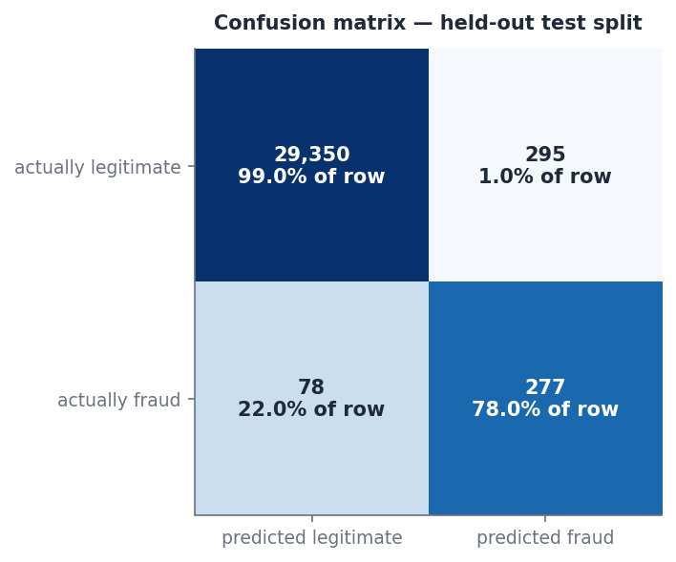
Fig. 6. V2 confusion matrix on the held-out test split, with row percentages.

10.5 Precision–Recall and ROC Analysis
Fig. 7 shows the V2 precision–recall curve (average precision 0.7326), against a no-skill baseline equal to the test prevalence (0.0118). The operating point lies at recall 0.780 and precision 0.484. Precision stays near 1.0 at low recall and declines steadily as recall increases beyond the operating region, so alerts become progressively diluted by false positives. Fig. 8 shows the ROC curve (ROC-AUC 0.9900), with the operating point at FPR 0.0100 and true-positive rate 0.780. Because the negative class is so large, the ROC curve rises almost vertically. The precision–recall view is the more informative of the two here [11], [12].
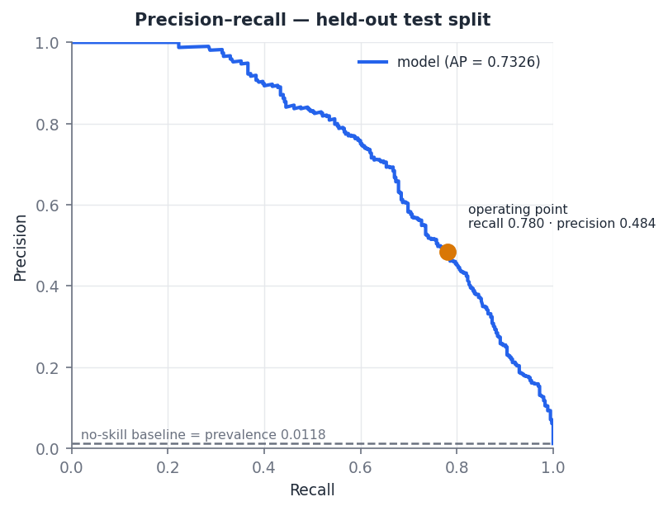
Fig. 7. Precision–recall curve of the frozen V2 model on the held-out test split. The dashed line is the no-skill baseline at the test prevalence.
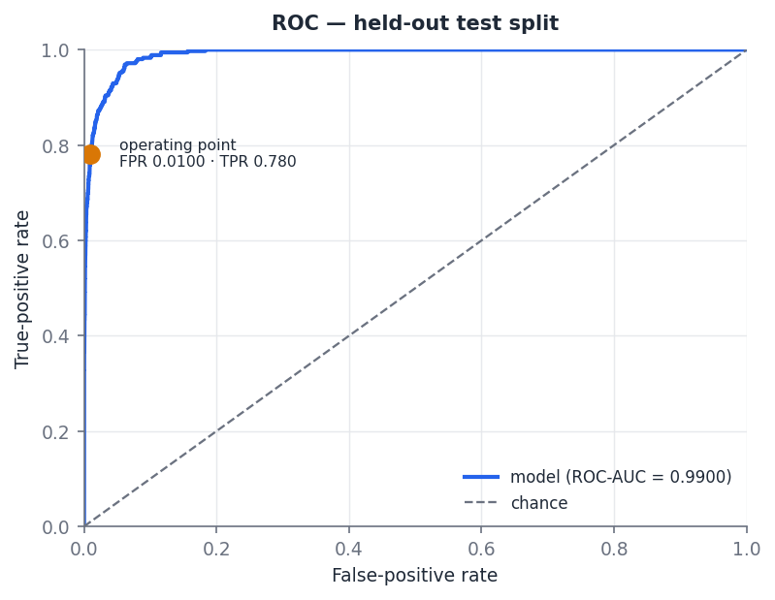
Fig. 8. ROC curve of the frozen V2 model on the held-out test split.

10.6 Recall at a Fixed False-Positive Rate
Fig. 9 shows the recall achievable as a function of FPR in the low-FPR region, with the 1% budget marked. At the validation-selected threshold, V2 recalls 0.780 of fraud at an FPR of 0.0100. Fig. 10 plots precision, recall and FPR against the decision threshold on a logarithmic axis, with the operating threshold of 0.1123 marked. It shows the trade-off that the budget resolves: lowering the threshold raises recall while FPR rises and precision falls.
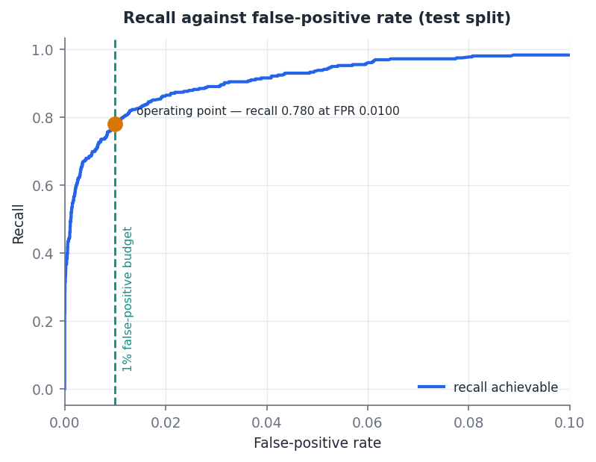
Fig. 9. Recall against false-positive rate for V2 on the test split; the dashed line marks the 1% budget.
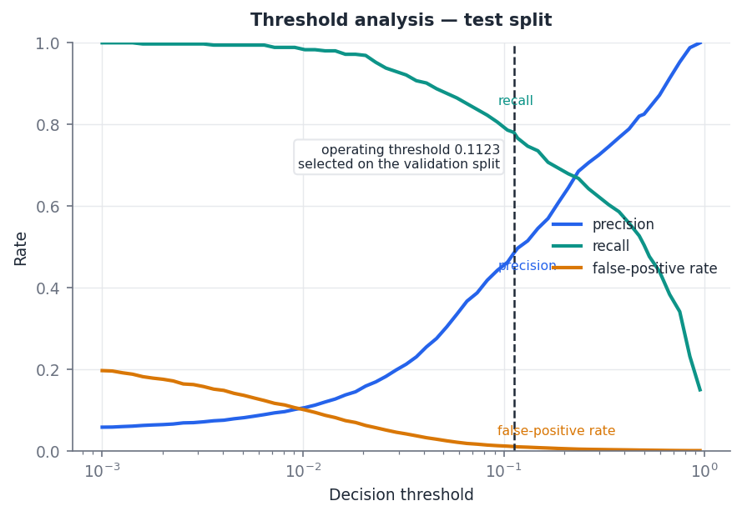
Fig. 10. Threshold analysis for V2 on the test split: precision, recall and FPR as functions of the decision threshold; the vertical line marks the operating threshold selected on validation.

10.7 Scenario-Wise Recall
Table VI and Fig. 11 report recall by scenario. V2 detects 120 of 182 social-engineering payments (65.93%), 68 of 80 mule-collection payments (85.00%), 69 of 73 account-takeover payments (94.52%) and all 20 card-testing payments (100.00%). Relative to V1, the gains are concentrated in the two scenarios in which the payer’s own behaviour is least informative. Social engineering remains the hardest scenario for both models.
TABLE VI. Scenario-wise recall on the held-out test split at each model’s validation-selected threshold.
Scenario | Test cases | V1 baseline | V2 primary
Social engineering | 182 | 19.23% (35) | 65.93% (120)
Mule collection | 80 | 63.75% (51) | 85.00% (68)
Account takeover | 73 | 94.52% (69) | 94.52% (69)
Card testing | 20 | 100.00% (20) | 100.00% (20)
Legitimate (FPR) | 29,645 | 0.945% (280) | 0.995% (295)
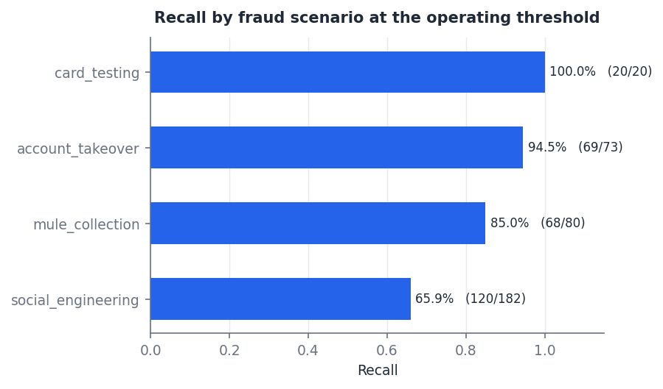
Fig. 11. V2 recall by fraud scenario at the operating threshold (detected/total in parentheses).

10.8 Calibration
Fig. 12 shows the V2 reliability curves. With quantile bins, only four bins are populated because most predictions lie near zero, and those points lie close to the diagonal. Fixed-width bins expose the upper range. The lowest bin (predicted probability below 0.1) contains 29,383 payments with a mean prediction of 0.0033 and an observed fraud rate of 0.0025. Intermediate bins show observed rates close to, or somewhat above, the mean predictions — for example, 0.435 observed against 0.347 predicted in the 0.3–0.4 bin, which contains 46 payments. The top bin contains 71 payments, all fraudulent, with a mean prediction of 0.973. The intermediate bins hold between 33 and 231 payments each, so their rates are estimated imprecisely. The Brier skill scores of 0.525 (V2) and 0.317 (V1) show that both calibrated models improve on the base-rate predictor. These results describe calibration on the simulator only.
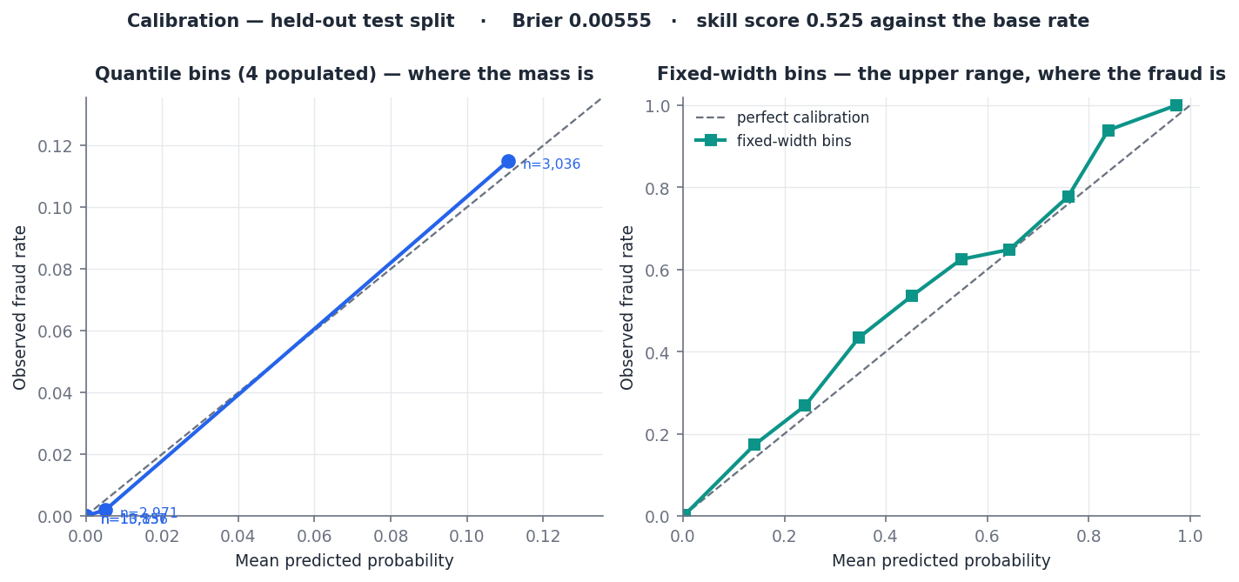
Fig. 12. Calibration of the frozen V2 model on the held-out test split: quantile bins (left) and fixed-width bins (right). Brier score 0.00555; skill score 0.525 against the base rate.

10.9 Feature Importance and SHAP
Fig. 13 shows V2 permutation importance, measured as the mean drop in test average precision when a feature is shuffled. The five highest-ranked features are:
- payee_is_new (0.3656);
- arrival_span_days (0.2455);
- amount_over_user_avg (0.2059);
- msg_coercion_probability (0.1379);
- component_size (0.1209).
The next five are txns_last_hour (0.1018), days_since_first_payment_to_payee (0.0765), seconds_since_last_txn (0.0732), lifespan_days (0.0587) and txns_today_over_avg (0.0534). Individual message-cue indicators, link features and availability flags have importances near zero, some slightly negative. For those features, shuffling makes no measurable difference to average precision once the other inputs are present.
Permutation importance indicates predictive usefulness under this test protocol, not causal influence. Correlated features can share or trade importance.
Fig. 14 shows mean absolute SHAP values for V2, computed on the uncalibrated first-fold booster over 200 test rows. By this measure payee_is_new is again the largest contributor, followed by arrival_span_days, amount_over_user_avg and component_size. The magnitudes are on the booster’s raw scale and do not decompose the calibrated probability.
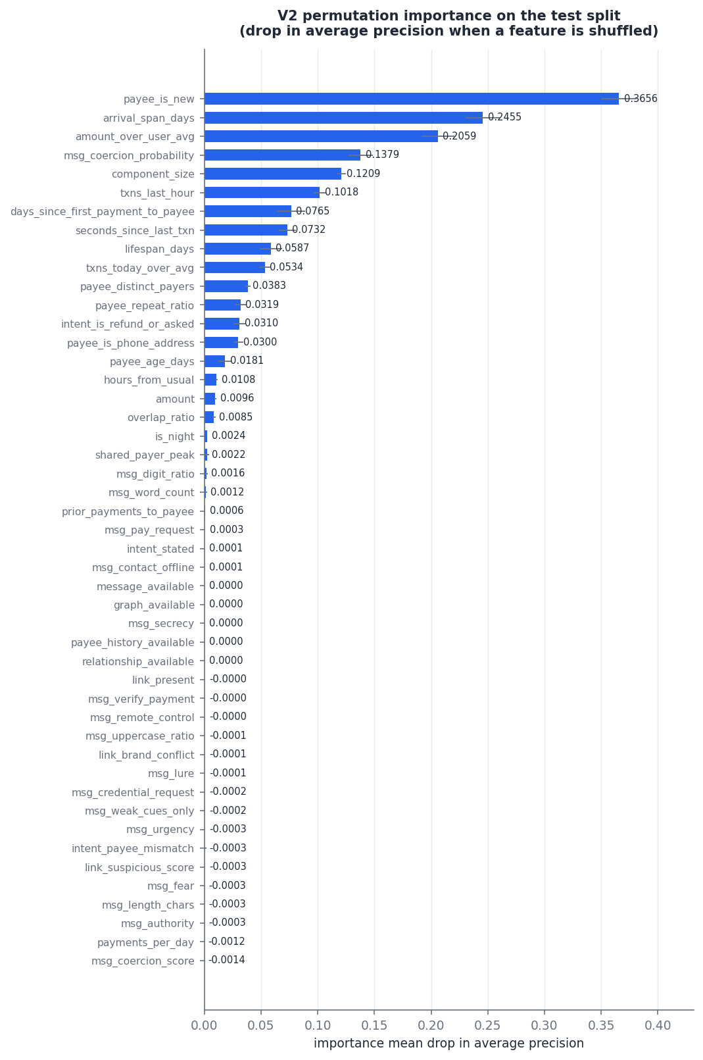
Fig. 13. V2 permutation importance on the test split (mean drop in average precision when a feature is shuffled; error bars over five repeats).
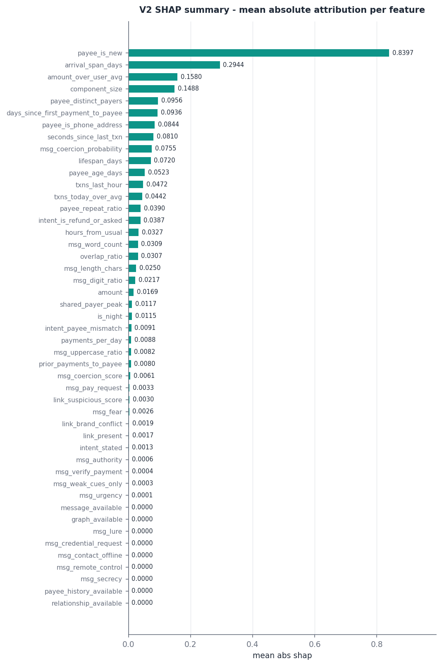
Fig. 14. V2 SHAP summary: mean absolute attribution per feature, computed with a tree explainer on the uncalibrated booster of the first calibration fold (200 test rows).

10.10 Ablation and Model-Family Comparison
Table VII reports the V2 ablation and model-family comparison. Every model in this table is uncalibrated and separately trained. Its full-V2 gradient-boosting row reaches a PR-AUC of 0.7234, which differs from the frozen calibrated V2 result of 0.7326 because the two belong to different protocols. The value 0.7234 is not the V2 result. Likewise, the uncalibrated V1-feature reference (0.4996) differs from the served V1 model (0.4860). The table should be read for differences between its own rows.
Within the ablation:
- adding the simulated graph group to C raises PR-AUC from 0.4562 to 0.5653;
- adding the simulated message, link and intent groups to C raises it to 0.5923;
- removing either group from the full set lowers PR-AUC, to 0.6298 without graph and 0.6101 without message, link and intent;
- removing the message channels reduces social-engineering recall most (to 36.8%), while removing the graph group reduces mule-collection recall most (to 60.0%).
Configuration C has twelve features but is not V1: it contains the payee phone-address flag and omits payee_is_new. Among model families on the full V2 features, gradient boosting (0.7234) exceeds a random forest (0.6915), extremely randomised trees (0.5145) and logistic regression (0.5055). These are single fits on one split, without significance tests.
TABLE VII. V2 feature-group ablation and model-family comparison (uncalibrated models; separately trained per row; threshold from validation; measured once on the test split). Not comparable in absolute terms with Table IV.
Configuration | Features | PR-AUC | Recall | FPR | SE recall | Mule recall
A. Payer timing + amount | 4 | 0.0970 | 0.163 | 0.0093 | 1.6% | 2.5%
B. A + payee | 9 | 0.3156 | 0.377 | 0.0096 | 17.6% | 57.5%
C. B + velocity | 12 | 0.4562 | 0.468 | 0.0096 | 17.0% | 61.3%
D. C + graph | 19 | 0.5653 | 0.546 | 0.0076 | 28.0% | 70.0%
E. C + message, link, intent | 36 | 0.5923 | 0.625 | 0.0106 | 47.8% | 60.0%
F. Full V2 — gradient boosting | 47 | 0.7234 | 0.766 | 0.0083 | 65.9% | 78.8%
Full V2 without graph | 40 | 0.6298 | 0.682 | 0.0104 | 57.1% | 60.0%
Full V2 without message, link, intent | 23 | 0.6101 | 0.620 | 0.0092 | 36.8% | 78.8%
V1 twelve features (reference) | 12 | 0.4996 | 0.496 | 0.0093 | 19.2% | 63.8%
Full V2 — random forest | 47 | 0.6915 | 0.744 | 0.0104 | 60.4% | 77.5%
Full V2 — extremely randomised trees | 47 | 0.5145 | 0.561 | 0.0099 | 49.5% | 38.8%
Full V2 — logistic regression | 47 | 0.5055 | 0.566 | 0.0103 | 48.9% | 37.5%

10.11 Missing-History Analysis
The observation mask hides payee history on 29,376 of 120,000 rows (24.48%). The simulated fraud prevalence is 1.729% among hidden-history rows and 1.005% among visible-history rows. The subsets therefore differ in simulated class distribution. This follows from the masking rule, which ties visibility to payer count, and it does not show that missing history causes or indicates fraud. Even among hidden-history rows, 98.3% of payments are legitimate. Because payee_history_available is a classifier input, the learned probability can respond to missingness; its V2 permutation importance, however, is 0.0000 (Fig. 13). The artefacts do not report detection performance separately for the two subsets.

10.12 Software Validation Results
Software tests validate implementation properties; they do not measure predictive accuracy. On the evaluated code base, 91 test cases in five modules (graph cache, graph semantics, evidence availability, evidence model and V2 dataset) passed. The graph-cache tests confirm that:
- the incremental maintenance behaves as specified;
- aggregates agree with the edge table;
- components merge correctly;
- failed updates roll back all structures;
- concurrent observations are safe;
- a pre-payment check changes no stored table and never invokes the dashboard’s full graph rebuild;
- a check issued at most two more queries after 400 further payments to other addresses were added;
- a later observation does not rewrite an earlier reading.
The evidence tests confirm that unavailable families carry no score or facts and that measured zeros are distinct from unavailable values. The dataset tests confirm that the V1 columns are unchanged when the V2 channels are appended. No latency benchmark is reported.

11. Discussion

11.1 V1 as the Baseline
The V1 results separate cleanly by scenario, and the pattern reflects the information V1 contains. Seven of its twelve features describe the payer. Account takeover and card testing depart from the payer’s usual behaviour, so they are detected at high rates. In social engineering the payer acts at an ordinary time and pace, and V1’s only view of the payee is its age, payer count and repeat ratio, which are unavailable for about a quarter of payments, together with payer-relative novelty. The ablation shows that payer and payee features are complementary for this scenario (+7.7 pp over the stronger half), but a social-engineering recall of 19.23% also shows that the V1 representation is insufficient for it.

11.2 Why V2 Improves over V1 in the Simulation
V2 adds relational, graph, message, link and stated-purpose channels, and under the synthetic protocol it raises PR-AUC from 0.4860 to 0.7326. Social-engineering recall rises from 19.23% to 65.93% and mule-collection recall from 63.75% to 85.00%, with 15 additional false positives. The improvement is consistent with the broader representation capturing additional simulated contextual signals. The permutation and SHAP rankings agree with the ablation. Payee novelty remains the most useful input. The arrival span and component size, both simulated graph features, rank among the five most useful inputs, as does the message-coercion probability. The ablation shows the message channels driving social-engineering recall and the graph channels driving mule-collection recall.
Two properties of the simulator limit how far this can be read. First, the scenario-conditional probabilities for the message, link and intent channels, and the graph-feature distributions, were set by the designers; whether real scam payments differ from legitimate ones in the same direction and degree has not been measured. Second, one message feature comes from a coercion model fitted on the same templated messages from which V2 draws. The size of the V1-to-V2 improvement is therefore not an estimate of real-world gain. What the experiment establishes more robustly is a property of the learning setup: a calibrated classical learner can use a heterogeneous representation in which whole groups are often missing, with explicit availability indicators, without missingness itself dominating. The availability flags have near-zero importance in Fig. 13.

11.3 Graph-Derived Evidence
The graph is intended to provide evidence invisible from a single payer’s history: how many distinct people pay an address, whether they return, how quickly they arrived, and whether they also pay another address with the same pattern. Two things have been shown, and they must be kept apart. The predictive experiments show that graph-derived feature channels contribute under a controlled simulation. Software tests show that the incremental implementation maintains its aggregates correctly and is read without modification or rebuild. What has not been shown is that the running graph, populated by real confirmations and statements, produces feature distributions like those the simulator assumes, or that its rule-based positional finding identifies collection accounts at any particular rate.

11.4 Missing Evidence and New Payees
Representing absent payee history explicitly avoids the most dangerous default for this problem: describing an unknown address as established. It also avoids the opposite error of warning on every first payment to a stranger. Even among hidden-history rows in this corpus, 98.3% of payments are legitimate. The implementation distinguishes two cases:
- an address never observed by the deployment receives a 6-point finding, below the WARN threshold, that can combine with other evidence;
- an unavailable family contributes no rule-based score.
Within the classifier, availability is a learned input. The corpus shows a higher simulated fraud prevalence among hidden-history rows, but that is a property of the masking rule, not an empirical finding about real data.

11.5 Calibration, Operating Point and Alert Burden
At the 1% FPR budget, V2 raises 572 alerts per 30,000 test payments, an alert rate of 1.9%, and slightly more than half of them (295) concern legitimate payments. Balanced class weighting shifts attention to the rare class, and isotonic calibration restores the probabilities to the observed scale. Neither changes the underlying dependence of precision on prevalence: at a lower real prevalence, the same FPR would yield a larger share of false alerts. Accuracy exceeds 98% for both models only because legitimate payments dominate, so it is not informative here. In the full architecture the classifier’s output is one bounded input. How aggregation changes the alert burden relative to the classifier alone was not measured.

11.6 Risk, Confidence and Verdicts
Reporting risk and coverage separately prevents a low score caused by missing evidence from looking like a low score caused by reassuring evidence. High coverage does not mean that a payment is safe, and low coverage does not mean that it is risky. The verdicts are advisory states. APPROVE means risk below the configured intervention threshold, not a guarantee. WARN presents evidence for the payer to see. STEP_UP recommends independent verification, and BLOCK is the highest band. The band boundaries are fixed design parameters, and this study did not evaluate alternative settings.

11.7 Explainability
The architecture offers two complementary explanations. Evidence findings, tied to named facts, are the primary user-facing reasons, because they refer to observations a payer can check. SHAP attributions, available through the explanation interface for V1 and computed offline for V2, describe how the classifier uses its inputs. The offline SHAP values explain the uncalibrated booster. Neither form of explanation establishes that a payment is fraudulent, and neither implies causality.

11.8 Relation to Prior Work
Table VIII compares the present work qualitatively with related approaches; no numerical comparison is made, because the datasets and tasks are incompatible.
- Transaction-level models [3]. These assess transactions from the account holder’s history. The V1 results illustrate their limitation for payer-authorised fraud.
- Spade+ [5]. It maintains dense-subgraph detection incrementally over a large industrial graph.
- PGLTSE [7]. It learns temporal graph representations with GNNs.
- The present system. It uses an incremental payer–payee graph with explicit graph features, a classical calibrated classifier and rule-based evidence aggregation. It is not a GNN, and it does not claim that explicit features match or exceed learned representations; it trades expressiveness for per-finding interpretability and bounded per-request cost on a small, partially observed graph.
- Secure UPI [8]. It motivates the domain but reports accuracy, which cannot be compared with the imbalance-aware measures used here.
TABLE VIII. Qualitative comparison with related approaches (no numerical comparison is implied).
Work | Data | Behavioural evidence | Payee / relational evidence | Graph | Temporal handling | Contextual evidence | Pre-payment focus | Explainability | Evaluation style
Dal Pozzolo et al. [3] | Real card transactions (industrial partner) | Yes | Not a focus | No | Concept drift, delayed feedback | Not reported | No | Not reported | Alert precision under realistic feedback
FRAUDAR [6] | Real graphs with injected and real fraud | No | Yes | Dense-subgraph detection | Static | No | No | Detected dense blocks | Detection of fraudulent blocks
CARE-GNN [9] | Review-fraud graphs | Node features | Yes | Graph neural network | Static | No | No | Not reported | AUC, recall
Spade+ [5] | Industrial and public transaction graphs | No | Yes | Incremental dense-subgraph peeling | Edge insertions and deletions | No | Real-time community detection (not per-payment advisory) | Suspicious communities | Detection and update efficiency
PGLTSE [7] | Real-world transaction datasets, incl. credit card | Via learned representations | Yes | Temporal graph learning (GNN) | Continuous-time dynamic graph | No | No | Not reported | AUC, AUPRC, recall, F1
Secure UPI [8] | Labelled UPI dataset (source not reported) | Transaction features | Not reported | No | Not reported | No | Not reported | Not reported | Accuracy
This work | Synthetic corpus (120,000 rows) | Yes | Yes | Incremental payer–payee graph; explicit features | Live path: pre-payment state; offline: sampled rows | Address/QR, amount, message, link, purpose | Yes (advisory) | Evidence findings; SHAP for classifier | PR-AUC, recall at 1% FPR, calibration, per-scenario recall, ablation; software tests

12. Threats to Validity and Limitations

12.1 Synthetic Data
No real UPI transaction data and no private UPI fraud corpus were used. All predictive results come from a simulator whose populations, scenarios and overlaps were specified by the authors. The prevalence of 1.183% and the scenario mixture are experimental settings, not estimates of real-world UPI fraud. Precision and PR-AUC depend on prevalence. The simulator also encodes the designers’ beliefs about which features distinguish fraud; where those beliefs are wrong, the model learns a pattern that does not exist, and an evaluation drawn from the same simulator cannot reveal it.

12.2 Simulator-Controlled V2 Channels and Message-Template Overlap
The V2 graph, message, link, intent and relationship channels are generated by the simulator. The coercion model that contributes one message feature was trained on the same 1,022-message templated pool from which V2 draws its messages, and that pool was written for the project rather than collected from real scam traffic. The message-channel results therefore do not show generalisation to unseen, real-world scam language, which varies far more in wording, language and script.

12.3 Graph Cache Not Used in the Predictive Experiment
The actual incremental graph cache is not executed in the V2 predictive experiment, because the corpus contains independent rows without payee identities or chronology. The graph-channel results describe simulated graph-derived features. The implementation is validated only through software tests, and the rule-based positional finding was not evaluated on labelled data.

12.4 No End-to-End Evaluation of the Full Architecture
The complete ten-family aggregation and verdict system was not evaluated end to end as an ML benchmark. The predictive results evaluate one family, the classifier. The rule-based families, damped-maximum aggregation, corroboration bonus and verdict bands were validated for correctness, not for detection performance. How often the full system issues each verdict for fraudulent and legitimate payments is therefore not established.

12.5 Temporal Replay
The pre-payment boundary is enforced structurally in the live path, but aggregates and the graph are read in their current state and are not time-indexed. Replaying historical payments against a store that already contains later payments does not reproduce the pre-payment state. In the offline corpus the boundary holds by construction, so the offline experiments do not test the live path’s temporal handling. Imported statements also depend on correct timezone normalisation and on the completeness of counterparty identifiers.

12.6 V1 Usual-Hour Missingness
When the payer’s usual hour is unavailable, V1 records hours_from_usual as 0, conflating an unmeasured deviation with a measured zero deviation. V2 inherits this encoding. The effect on the reported metrics was not isolated.

12.7 Provider Verification Not Configured
The prototype has no NPCI, bank or PSP integration. The repository’s optional provider-verification interface was not configured, so no real-time external verification occurs, and no experimental payee is VERIFIED.

12.8 Distribution Shift and Calibration
Real transaction behaviour, scam language, merchant populations, VPA patterns, graph structure, observation coverage and fraud prevalence may differ substantially from the simulator, and fraud adapts over time [3]. The isotonic calibrators were fitted on roughly 170 fraudulent examples per training fold, and calibration may change under real-world prevalence. All results come from one seed and one split, without confidence intervals.

12.9 Security and Deployment
Four issues remain present in the prototype’s current code:
- the graph endpoint (/fraud-graph) returns stored payer–payee edges, and therefore other users’ payment relationships, to any authenticated caller;
- the health endpoint (/health) is unauthenticated and reports library versions;
- the assistant endpoint (/chat) can return provider error text in a diagnostic field;
- payee reports (/payee/report) are counted by distinct reporter but are not rate-limited.
An advisory layer is also an attack surface: an adversary who can observe verdicts, or submit reports and confirmations, can attempt to probe or shape the evidence. These issues must be resolved before any deployment beyond a controlled prototype.

12.10 Repository Reproducibility State
At the time of writing, the evaluated working tree contained 81 uncommitted changes, including service files. The module clock.py, which provides time normalisation, was untracked. The script evaluate_model_v2.py did not match the hash recorded in its manifest. The principal model and data artefacts do match their recorded hashes: the V1 and V2 model files, both metrics files, both dataset generators and feature modules, the training script, the message corpus and the coercion weights. The repository also contains a module named temporal_gnn.py; despite its name, it implements an hour-of-day histogram and is not a graph neural network. A tagged commit is required before the code accompanies this paper.

12.11 No Production Deployment Claim
The system has not been deployed in production, and nothing in this paper is a measurement of production performance. The simulator gives reproducibility and control at the cost of ecological validity.

13. Conclusion and Future Work
This study set out to test whether a pre-payment assessment for UPI-style payments can combine payer behaviour, observed payee history, relational structure and payment context while remaining honest about what it does not know. The resulting architecture shows that this combination is feasible within one advisory assessment:
- ten evidence families each declare their availability and the typed facts they rely on;
- an incremental payer–payee graph supplies explicit relational quantities without per-request rebuilding;
- a damped-maximum rule with fact-aware corroboration keeps several families from counting one observation repeatedly;
- risk and coverage are reported as separate quantities;
- every rule-based contribution to risk can be explained as a named finding.
Several of these properties hold by construction and are checked by software tests rather than by the simulator. They include the read-only assessment path, the separation of unavailable from measured evidence, and the bounded classifier contribution.
The predictive experiments evaluate the classifier component under controlled synthetic conditions. The V1 baseline retained by the prototype reaches a PR-AUC of 0.4860 but detects only 19.23% of social-engineering payments. The expanded V2 research configuration, frozen and evaluated offline, reaches a PR-AUC of 0.7326 and a recall of 0.7803 at an FPR of 0.00995, with well-calibrated probabilities on the simulator. Payee novelty, arrival timing and message coercion were among its most useful inputs. The direction of this result supports the premise that payee-side, relational and contextual evidence matters for payer-authorised fraud. Its magnitude does not transfer to real payments, because the added channels were generated by the same simulator and the message features overlap with their training templates.
Future work should address these limitations directly:
- evaluation on independent real-world transaction data;
- externally validated, multilingual scam-message corpora;
- end-to-end evaluation of the incremental graph and of the complete ten-family verdict system through chronological replay with time-indexed aggregates;
- testing on held-out, unseen scam patterns;
- independent calibration assessment at realistic prevalence, with repeated runs;
- deployment-scale latency measurement;
- privacy-preserving validation with financial institutions;
- stronger graph learning, only if real graph data show that explicit features are insufficient;
- mobile and provider integration under appropriate security review and authorisation, once the issues in Section 12.9 are resolved.
None of these extensions is implemented in the present prototype.

References
[1] S. Rastogi, C. Panse, A. Sharma, and V. M. Bhimavarapu, “Unified Payment Interface (UPI): A digital innovation and its impact on financial inclusion and economic development,” Universal J. Accounting Finance, vol. 9, no. 3, pp. 518–530, 2021, doi: 10.13189/ujaf.2021.090326.
[2] R. J. Bolton and D. J. Hand, “Statistical fraud detection: A review,” Statist. Sci., vol. 17, no. 3, pp. 235–255, 2002, doi: 10.1214/ss/1042727940.
[3] A. Dal Pozzolo, G. Boracchi, O. Caelen, C. Alippi, and G. Bontempi, “Credit card fraud detection: A realistic modeling and a novel learning strategy,” IEEE Trans. Neural Netw. Learn. Syst., vol. 29, no. 8, pp. 3784–3797, Aug. 2018, doi: 10.1109/TNNLS.2017.2736643.
[4] J. Braithwaite, “‘Authorized push payment’ bank fraud: What does an effective regulatory response look like?,” J. Financial Regulation, vol. 10, no. 2, pp. 174–193, 2024, doi: 10.1093/jfr/fjae006.
[5] J. Jiang, Y. Chen, B. He, M. Chen, and J. Chen, “Spade+: A generic real-time fraud detection framework on dynamic graphs,” IEEE Trans. Knowl. Data Eng., vol. 36, no. 11, pp. 7058–7073, Nov. 2024, doi: 10.1109/TKDE.2024.3394155.
[6] B. Hooi, H. A. Song, A. Beutel, N. Shah, K. Shin, and C. Faloutsos, “FRAUDAR: Bounding graph fraud in the face of camouflage,” in Proc. 22nd ACM SIGKDD Int. Conf. Knowl. Discovery Data Mining, 2016, pp. 895–904, doi: 10.1145/2939672.2939747.
[7] J. Ma, S. Xiang, Q. Li, L. Yuan, D. Cheng, and C. Jiang, “Parallel graph learning with temporal stamp encoding for fraudulent transactions detections,” IEEE Trans. Big Data, vol. 11, no. 4, pp. 1945–1958, 2025, doi: 10.1109/TBDATA.2024.3499338.
[8] R. Rani, A. Alam, and A. Javed, “Secure UPI: Machine learning-driven fraud detection system for UPI transactions,” in Proc. 2nd Int. Conf. Disruptive Technol. (ICDT), 2024, pp. 924–928, doi: 10.1109/ICDT61202.2024.10489682.
[9] Y. Dou, Z. Liu, L. Sun, Y. Deng, H. Peng, and P. S. Yu, “Enhancing graph neural network-based fraud detectors against camouflaged fraudsters,” in Proc. 29th ACM Int. Conf. Inf. Knowl. Manage. (CIKM), 2020, pp. 315–324, doi: 10.1145/3340531.3411903.
[10] M. Weber, G. Domeniconi, J. Chen, D. K. I. Weidele, C. Bellei, T. Robinson, and C. E. Leiserson, “Anti-money laundering in Bitcoin: Experimenting with graph convolutional networks for financial forensics,” arXiv:1908.02591, 2019.
[11] T. Saito and M. Rehmsmeier, “The precision-recall plot is more informative than the ROC plot when evaluating binary classifiers on imbalanced datasets,” PLoS ONE, vol. 10, no. 3, Art. no. e0118432, 2015, doi: 10.1371/journal.pone.0118432.
[12] J. Davis and M. Goadrich, “The relationship between precision-recall and ROC curves,” in Proc. 23rd Int. Conf. Mach. Learn. (ICML), 2006, pp. 233–240, doi: 10.1145/1143844.1143874.
[13] A. Niculescu-Mizil and R. Caruana, “Predicting good probabilities with supervised learning,” in Proc. 22nd Int. Conf. Mach. Learn. (ICML), 2005, pp. 625–632, doi: 10.1145/1102351.1102430.
[14] B. Zadrozny and C. Elkan, “Transforming classifier scores into accurate multiclass probability estimates,” in Proc. 8th ACM SIGKDD Int. Conf. Knowl. Discovery Data Mining, 2002, pp. 694–699, doi: 10.1145/775047.775151.
[15] G. W. Brier, “Verification of forecasts expressed in terms of probability,” Monthly Weather Rev., vol. 78, no. 1, pp. 1–3, 1950.
[16] J. H. Friedman, “Greedy function approximation: A gradient boosting machine,” Ann. Statist., vol. 29, no. 5, pp. 1189–1232, 2001, doi: 10.1214/aos/1013203451.
[17] E. A. Lopez-Rojas, A. Elmir, and S. Axelsson, “PaySim: A financial mobile money simulator for fraud detection,” in Proc. Eur. Model. Simul. Symp. (EMSS), 2016, pp. 249–255.
[18] N. V. Chawla, K. W. Bowyer, L. O. Hall, and W. P. Kegelmeyer, “SMOTE: Synthetic minority over-sampling technique,” J. Artif. Intell. Res., vol. 16, pp. 321–357, 2002, doi: 10.1613/jair.953.
[19] G. Ke, Q. Meng, T. Finley, T. Wang, W. Chen, W. Ma, Q. Ye, and T.-Y. Liu, “LightGBM: A highly efficient gradient boosting decision tree,” in Proc. Adv. Neural Inf. Process. Syst. (NIPS), vol. 30, 2017, pp. 3146–3154.
[20] S. M. Lundberg and S.-I. Lee, “A unified approach to interpreting model predictions,” in Proc. Adv. Neural Inf. Process. Syst. (NIPS), vol. 30, 2017, pp. 4765–4774.
[21] F. Pedregosa et al., “Scikit-learn: Machine learning in Python,” J. Mach. Learn. Res., vol. 12, pp. 2825–2830, 2011.
[22] L. Breiman, “Random forests,” Mach. Learn., vol. 45, no. 1, pp. 5–32, 2001, doi: 10.1023/A:1010933404324.

